Business Rules

Business Rules:
- Business rules are used to provide custom validation logic for objects.
- These rules are used to determine eligibility of an object to go through defined checkpoints in the change management or promotion processes.
- You can require feedback on the result of the evaluation.
- The result of the Business Rules is the reduction of manual work to validate business data and errors in the enterprise due to incorrect information.
Example: For example, before objects are released through the Change Notice workflow, you must ensure that none of the Resulting Objects are checked out. You can make a Business Rule to perform this validation.

Prerequisites:
- Basic development involving Java and XML.
- The management of Windchill properties.
- Basic overview of Business Rules usage.

Change Association Rule Administration:
- You can use change associations to configure relationships between change objects.
- For example, you can configure the relationship between a manufacturing change notice to an engineering change notice, a problem report to a change notice, or an item-specific change request to a block change request.
- Change association rules define relationships when linking change objects in the following tables:
- Associated Process Objects
- Associated Reference Objects
- Implementation Plan
- Site and organization administrators can create, modify, and view change association rules using the Change Association Rules table:
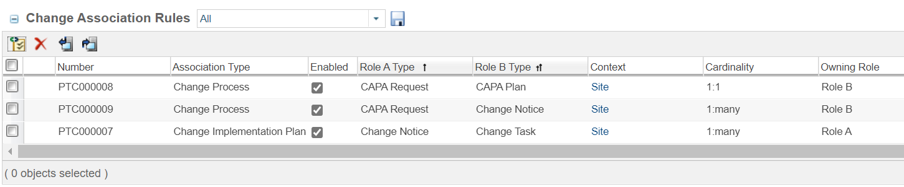

Change Association Rules Table:
- To access this table, navigate to the Utilities page under Site or Organizations. Select Business Rules.
Note:
The Change Association Rules table is available at the organization level when the wt.associationRules.enableOrganizationRules property is set to true. By default, this property is set to false.
If you define rules at the organization level, those rules are preferred over site-level rules.

Refer Article - CS254572

Table Columns:

General Status | A status indicator appears when an object is checked out to you or another user.
Number | A system-generated number for the rule.
Association Type | The process type or a reference type:  - Change Process—Configure which objects can be linked as part of the same change process. This also dictates the applicable object types available to add to the Associated Process Objects table.  - Change Reference—Configure which objects can be linked as references, but are not necessarily included in the same change process. This also dictates the applicable object types available to add to the Associated Reference Objects table.  - Change Implementation Plan—Configure the association between a change notice and its tasks.  - Impact—Configure the association between objects that impact each other in order to execute specific actions on those objects. For example, a change task impacting variant baseline members.
Enabled | When this checkbox is selected, the rule is enabled and available for use.
Role A Type | The Role A object is typically the parent object. However, depending on the association type, either the Role A or Role B object can be the owning object or required object.
Role B Type | In some situations, both Role A and Role B might be assigned to the same object type. For example, you create a rule in which both Role A and Role B are assigned to the change request object type.  Role assignment is determined as follows:  • Owning role—If the owning role is set and you only have the required permissions for one object in the relationship, then the owning role is assigned to the object.  For example, the owning role is set to Role B. You modify a change request named “Request 1” and add a pre-existing change request (Request 2) to the Associated Changes table. You have modify permission to Request 1, but not to Request2. As a result, Request 1 is assigned the value of the owning role (Role B).  • Context—If the owning role is not set, or if you have the same permissions for both objects, then roles are assigned using the context of the action you are performing. The object on which you are performing the primary action is considered the Role A object.  For example, you modify a change request named “Request 1” and add a pre-existing change request (“Request 2”) to the Associated Changes table. In this situation, Request 1 is the Role A object.
Context | Site or Organization  If you define rules at the organization level, those rule are preferred over site-level rules.
Cardinality | The cardinality determines the number of Role B objects that are allowed in relation to the Role A object.
Owning Role | The owning role allows you to restrict who can create, delete, or modify associations.  To create a link, users must have modify access to the owning role object. Furthermore, the non-owning role object can only be deleted if the user has modify access to the owning role object.
Required Role | The required role identifies associations between objects that are required. If the user attempts to create an object without adding the required role, an error message appears.
Link Type | The link type matches the selected Association Type.  • Change Process Link  • Change Reference Link  • Implemented By  • Impact Link

Define Change Association Rules:

- You can create and modify change association rules from the Change Association Rules table.
- To access this table, navigate to the Utilities page under Site or Organizations. Select Business Rules.

Note:
You can create rules at the organization level when the wt.associationRules.enableOrganizationRules property is set to true. By default, this property is set to false.
If you define rules at the organization level, those rule are preferred over site-level rules.

Creating the Change Association Rule:

- From the Change Association Rules table, click the new change association rule icon.
- Complete the following fields under Type Attributes:
Association Type | Select one of the following options:  • Change Process—Configure which objects to link as part of the same change process. This also dictates the applicable object types available to add to the Associated Process Objects table.  • Change Reference—Configure which objects can be linked as references, but are not necessarily included in the same change process. This also dictates the applicable object types available to add to the Associated Reference Objects table.  • Change Implementation Plan—Configure the association between a change notice and change tasks.  • Impact—Configure the association between objects that impact each other in order to execute specific actions on those objects. For example, a change task impacting baseline members.  The selection you make under the Association Type field determines the options that are available from the Role A Type and Role B Type fields.
Role A Type | Select an object type to represent Role A in the link relationship.  The Role A object is typically the parent object. However, either Role A or Role B can be the owning object or required object.  Options include the following:  • Flexible Change Item  • CAPA Plan  • CAPA Request  • Change Notice  • Change Request  • Customer Experience  • Nonconformance  • Problem Report  • Variance  The types that appear vary based on the solutions installed at your site.  Custom subtypes created at your site also appear.
Role B Type | Select an object type to represent Role B in the link relationship.  • Flexible Change Item  • CAPA Plan  • CAPA Request  • Change Notice  • Change Request  • Customer Experience  • Nonconformance  • Problem Report  • Variance  The types that appear vary based on the solutions installed at your site.  Custom subtypes created at your site also appear.

- Complete the following fields under Instance Attributes.
The options that are available for each field depend on the selections you make under the Type Attributes fields.
Cardinality | The cardinality determines the number of Role B objects that are allowed in relation to the Role A object.  Select one of the following options:  many:many  1:many or many:1  1:many  many:1  1:1  For example, you define Role A as a problem report, and Role B as a change request:  • 1:many—A problem report can be linked to multiple change requests. Each change request can only be linked to a single problem report.  • 1:1—Each problem report can only be linked to a single change request. Each change request can only be linked to a single problem report.  • many:1—Each problem report can only be linked to a single change request. However, a change request can be linked to multiple problem reports.  • 1:many or many:1—The link is limited depending on which association is created first. For example, a problem report is linked to a single change request:  ◦ You associate a second change request to the problem report. A 1:many cardinality is enforced. The problem report can be linked to multiple change requests, but the change request can only be linked to a single problem report.  ◦ You associate a second problem report to the change request. A many:1 cardinality is enforced. The change request can be linked to multiple problem reports, but the problem report can only be linked to a single change request.
Owning Role | The owning role allows you to restrict who can create, delete, or modify associations.  To create a link, users must have modify access to the owning role object. Furthermore, the non-owning role object can only be deleted if the user has modify access to the owning role object.  Select one of the following options:  None  Role A  Role B  For example, you define Role A as a problem report, and Role B as a change request. The owning role is:  • Role A—If a user wants to create an association between a problem report and a change request, they must first have modify access to the problem report. Furthermore, once the association is created, the change request can only be deleted by users who have modify access to the problem report.  • Role B—If a user wants to create an association between a problem report and a change request, they must first have modify access to the change request. Furthermore, once the association is created, the problem report can only be deleted by users who have modify access to the change request.
Required Role | The required role identifies associations between objects that are required. If the user attempts to create an object without adding the required role, an error message appears.  Select one of the following options:  None  Role A  Role B  For example, you define Role A as a problem report, and Role B as a change request. The required role is:  • Role A—When a user creates a new change request, they must add a problem report as an associated object. Otherwise, the user receives an error message.  • Role B—When a user creates a new problem report, they must add a change request as an associated object. Otherwise, the user receives an error message.

- Click OK.

Required Role Constraint
The Required Role is a constraint to create an association between the change objects. You must select the Required Role value to create the Role A Type or Role B Type change object.
For example, the following table explains the required role constraint and description for creating change objects:
Association Rules | Role A Type Change Object | Role B Type Change Object | Required Role | Description
Rule 1 | Problem Report | Prototype Change Notice | None | The Required Role (None) is a constraint to create change object. You can create Role B type change object (Prototype Change Notice) without Role A type change object (Problem Report). Or You can create Role A type change object (Problem Report) without Role B type change object (Prototype Change Notice).
Rule 2 | Problem Report | Production Change Request | Role A | The Required Role (Role A) is a constraint to create change object. You cannot create Role B type change object (Production Change Request) without Role A type change object (Problem Report).
Rule 3 | Production Change Request | Production Change Notice | Role B | The Required Role (Role B) is a constraint to create change object. You cannot create Role A type change object (Production Change Request) without creating Role B type change object (Production Change Notice).

The wt.change2.associationRuleEvaluateRequiredRole.enabled property controls the visibility of the Role A or Role B type change object during the creation of a change object. Based on the required role under the Change Association Rules, creating the change object violates the required role constraint of association rule.
If set to true, either the Role A type or Role B type change object that you want to create is not visible based on the required role under the Change Association Rules.
Consider the following scenario when creating the change object. If Role B is Required Role, then Role A type change object will not be visible. If Role A is Required Role, then Role B type change object will not be visible. As a result, you cannot create the change object at the initial step.
If set to false, either the Role A type or Role B type change object that you want to create is visible based on the required role under the Change Association Rules. However, at the final step of creating the change object, you will receive an error message stating that creating the change object violates the required role constraint of the association rule.
The default value is false. An administrator can set the property.

Example-1:
- Follow the below steps to create Change Association Rules.
- For testing purpose creating a rule which should not allow Change Notice creation without associating related Change Request.
- Navigate to Site or Organization Utilities Business Rules.
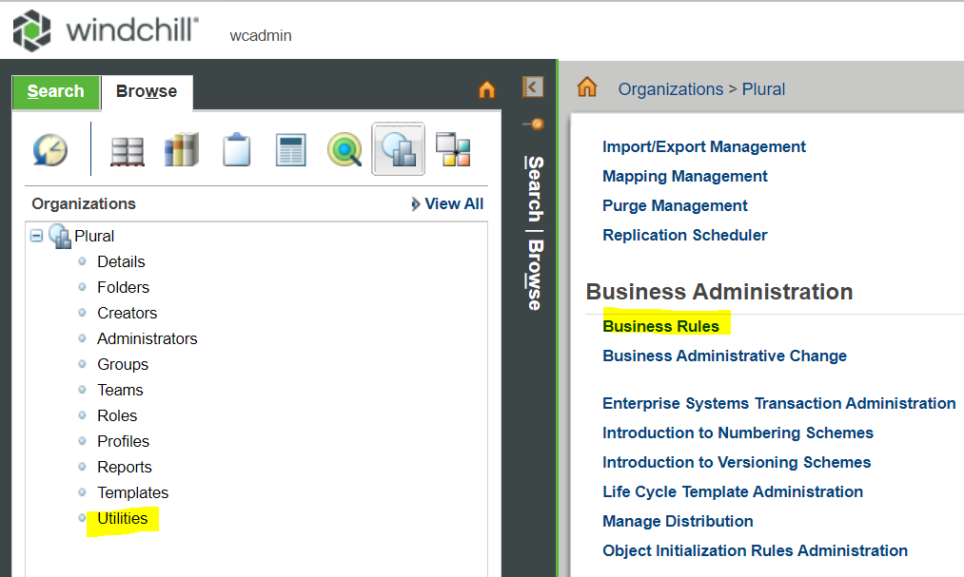

- Click on New Change Association Rule.
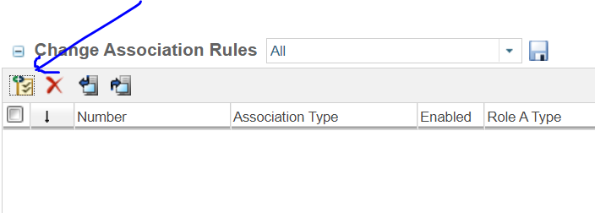

- Provide the info as shown below for creating reference link between Change Notice and Change Request.
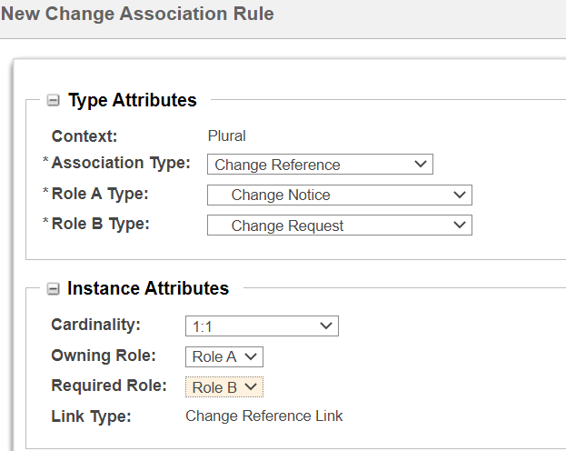

- Now try to create a CN without associating CR and validate.
- Observed the below ATTENTION message when trying to create a CN without associating a CR.
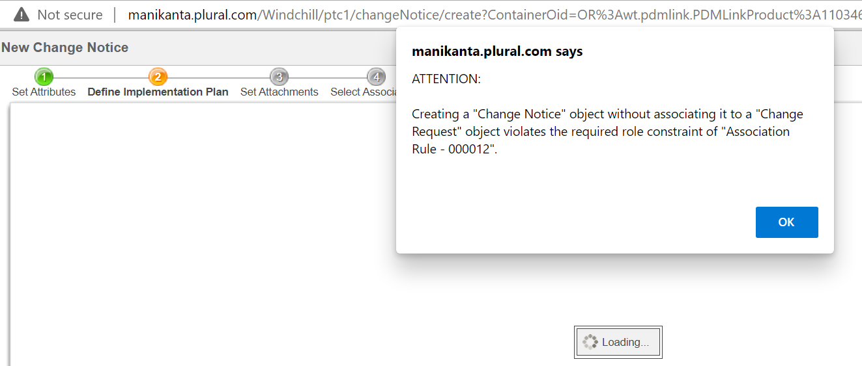

- After associating the CR to CN, it did not report any attention message.

Reference Link: Change Association Rule Administration

Business Rule Objects
There are three business rule objects:
• BusinessRuleSet—The persistence configuration used to navigate the persistent set of validation business rules for a context. This configuration can be overridden at the context level.
• BusinessRule—Information about the rule to be executed. Each rule can have unique configuration requirements associated with it. The selector is mapped to the actual implemented rule validation class.
• BusinessRuleLink—The object-to-object binary link holding the references to BusinessRuleSet and BusinessRule. Each BusinessRuleSet is associated with a BusinessRule using the BusinessRuleLink.
Each business rule object has a set of attributes:
BusinessRuleSet | uniqueKey, name, description, enabled, overridable
BusinessRule | uniqueKey, name, description, configs, enabled
BusinessRuleLink | blockNumber

Attribute | Required? | Type | Description
uniqueKey | Yes | String | Unique key for a given context.  The string can be up to 256 characters.
name | Yes | String | Localized resource key to describe the name of the object.  The string can be up to 256 characters.
description | No | String | Localized brief description of the business rule object.  The string can be up to 4000 characters.
configs | No | Name-value pair | The information that can be used to configure variations for a give business rule. You can optionally define one or more elements in the configs attribute.  Each configs attribute can hold multiple configurations of name and value pairs.
enabled | No | Boolean | Indicates the ability to configure the business rule object to be executed. When the value is false, the business rule object is ignored. The next enabled object in the context hierarchical lookup is used.
overridable | No | Boolean | Indicates if a lower-level context business rule instance can override a rule defined at a higher level. If false, the business rule instance of the top-level context is used.
blockNumber | No | Integer | Indicates the execution order of the rules. You can configure multiple rules to the same blockNumber, but there is no guarantee of order. A value of 1 indicates the first rule to be executed within the business rule set.

Available Business Rules
The available business rules validate the following:
• Checkout Rule—Objects are not checked out or checked out to a project.
• Attribute Rule—Specified attributes meet certain conditions
• Release Target Rule—All resulting objects are at an appropriate state for release and have an appropriate change management transition specified that is consistent with the assigned life cycle transition rules
• BOM Release Rule—All resulting objects are at an appropriate state and all their first-level dependants are at an appropriate state
These rules can be extended or overridden by registering a new rule validation class for the rule selector in service.properties. For more information about registering a new rule validation class, see the Windchill Customization Guide.
If the business rule fails, you can view the cause by clicking View Conflicts on the Audit Change Notice and the Resolve Release Conflicts task pages.

Checkout Rule
The Checkout rule validates that objects are not checked out to a user or checked out to a project.

Example
The following XML example defines a set of business rule objects that implement the checkout rule.
Business rule set:
<?xml version="1.0" encoding="UTF-8" ?>
<!DOCTYPE BusinessRuleSet SYSTEM "standardX20.dtd">
<BusinessRuleSet>
<ObjectID><localId>wt.businessRules.BusinessRuleSet:45346</localId></ObjectID>
<key>CHANGEABLE_PRE_RELEASE</key>
<name>com.ptc.windchill.enterprise.change2.change2ClientResource:
CHANGE_PRE_RELEASE_RULESET_NAME</name>
<description>com.ptc.windchill.enterprise.change2.change2ClientResource:
CHANGE_PRE_RELEASE_RULESET_DESC</description>
<enabled>true</enabled>
<overridable>true</overridable>
</BusinessRuleSet>
Business rule:
<?xml version="1.0" encoding="UTF-8" ?>
<!DOCTYPE BusinessRule SYSTEM "standardX20.dtd">
<BusinessRule>
<ObjectID><localId>wt.businessRules.BusinessRule:158915</localId></ObjectID>
<key>CHECKOUT_RULE</key>
<selector>CHECKOUT_RULE</selector>
<name>com.ptc.windchill.enterprise.change2.change2ClientResource:
CHECK_OUT_VALIDATOR_RULE_NAME</name>
<description>com.ptc.windchill.enterprise.change2.change2ClientResource:
CHECK_OUT_VALIDATOR_RULE_DESC</description>
<enabled>true</enabled>
</BusinessRule>
Business rule link:
<?xml version="1.0" encoding="UTF-8" ?>
<!DOCTYPE BusinessRuleLink SYSTEM "standardX20.dtd">
<BusinessRuleLink>
<ObjectID><localId>wt.businessRules.BusinessRuleLink:158919</localId></ObjectID>
<ruleSet><ObjectReference><localID>wt.businessRules.BusinessRuleSet:45346</localId>
</ObjectReference></ruleSet>
<rule><ObjectReference><localID>wt.businessRules.BusinessRule:158915</localId>
</ObjectReference></rule>
<blockNumber>1</blockNumber>
</BuisnessRuleLink>

Attribute Rule
The attribute rule validates that specified attributes meet certain conditions. The object type is the only required input for an attribute rule configuration. The object type should be a wt.fc.Persistable type object. For example, com.ptc.Waiver is a subtype of wt.change2.WTVariance.
<configs>
<config name="objectType" value="com.ptc.Waiver"></config>
</configs>
You can specify the type name or the type string value by using only the type external name (com.ptc.Waiver or WCTYPE|wt.change2.WTVariance|com.ptc.Waiver )
You can exclude subtypes of the specified object type from the attribute rule. For example, the following attribute rule configuration for object type WTVariance would exclude com.ptc.Waiver and com.ptc.Deviation type variances from being evaluated.
<configs>
<config name="objectType" value="wt.change2.WTVariance "></config>
<config name="excludedType" value="com.ptc.Waiver"></config>
<config name="excludedType" value="com.ptc.Deviation"></config>
</configs>
To configure a condition that validates against an attribute of the specified object type, the configuration name is Attribute Name and the value is Condition. The following attribute configuration checks if a com.ptc.Waiver has an approved quantity between 10 and 100.
<configs>
<config name="objectType" value="com.ptc.Waiver"></config>
<config name="approvedQuantity" value="[10..100]"></config>
</configs>
The following is an example where weight is the internal name of a global attribute on some subtype of part.
<configs>
<config name="objectType" value="com.ptc.SubTypePart"></config>
<config name="weight" value="<=100"></config>
</configs>
The following table shows the supported operations and object types supported in attribute rule configuration.

Operator | Value Types | Description | Example Load Conditions
>, >=, <, <= | Long, String, Date, Timestamp, FloatingPoint, FloatingPointWithUnits | Validates that the object attribute value is greater than, greater than or equal to, less than, or less than or equal to the value specified.  The operator characters are reserved characters in the import load; the less than operator (<) needs to be specified as ‘&lt;’ and greater than operator (>) as ‘&gt;’. | &gt;2012-01-12 00:00:00=&lt;=20.002&gt;=10
[0..10] | Long, String, Date, Timestamp, FloatingPoint, FloatingPointWithUnits | Validates that the object attribute value is within the specified range. If no minimum value in the range is specified, the condition is equivalent to less than or equal to. If the maximum value in the range is not specified, the condition is treated a greater than or equal to. | [-10.09..10.09][2012-01-12 00:00:00..2012-02-12 00:00:00][..100][0..]
=, != | Boolean, Long, String, Date, Timestamp, FloatingPoint, FloatingPointWithUnits | Validates that the object attribute value is or is not the value specified.  The operator character ! is a reserved character in the import load; it must be specified as ‘#33;’ | =true#33;=2012-02-12 00:00:00=10.09
[A,B] | Boolean, Long, String, Date, Timestamp, FloatingPoint, FloatingPointWithUnits | Validates that the object attribute value is within the discrete set. | [true][2012-02-01 00:00:00,2012-02-15 00:00:00,2012-02-30 00:00:00][MAJOR,CRITICAL][10.01,10.02][10,100,1000]
SET | Boolean, Long, String, Date, Timestamp, FloatingPoint, FloatingPointWithUnits | Validates that the object attribute value is not null. Only the keyword SET is needed to specify the operation. | SET
NOT_SET | Boolean, Long, String, Date, Timestamp, FloatingPoint, FloatingPointWithUnits | Validates that the object attribute value is null. Only the keyword NOT_SET is needed to specify the operation. | NOT_SET
EQUALS | String | Validates that the object attribute value is the specified string. | EQUALS(MAJOR)
NOT_EQUALS | String | Validates that the object attribute value is not the specified string | NOT_EQUALS(MAJOR)
BEGINSWITH | String | Validates that the object attribute value starts with a specified string. | BEGINSWITH(PN)
NOT_BEGINSWITH | String | Validates that the object attribute value does not start with a specified string. | NOT_BEGINSWITH(PN)
ENDSWITH | String | Validates that the object attribute value ends with a specified string. | ENDSWITH(0)
NOT_ENDSWITH | String | Validates that the object attribute value does not end with a specified string. | NOT_ENDSWITH(0)
CONTAINS | String | Validates that the object attribute value contains the specified string. | CONTAINS(PN0)
NOT_CONTAINS | String | Validates that the object attribute value does not contain the specified string. | NOT_CONTAINS(PN0)
LENGTH | String | Validates that the object attribute string length is within the specified range. | LENGTH(0..40)LENGTH(0..)LENGTH(..40)

The system locale is used for the format of the dates and timestamps in the attribute condition.
Example
Suppose you have a specific subtype of a part that has an attribute called weight to represent how heavy the part is. Before releasing parts that have a weight, you want to ensure that a weight is set to a reasonable figure. In order to do this, construct a business rule to verify the weight attribute falls within the range 1-100.
Business rule set:
<?xml version="1.0" encoding="UTF-8" ?>
<!DOCTYPE BusinessRuleSet SYSTEM "standardX20.dtd">
<BusinessRuleSet>
<ObjectID><localId>wt.businessRules.BusinessRuleSet:45347</localId>
</ObjectID>
<objectContainerPath>/wt.inf.container.OrgContainer=
BusinessRulesTestOrganization/wt.pdmlink.PDMLinkProduct=
BusinessRulesTestProduct</objectContainerPath>
<key>CHANGEABLE_PRE_RELEASE</key>
<name>Test_Changeable_ReleaseRuleSet</name>
<description>To test basic Attribute RuleSet Validation</description>
<enabled>true</enabled>
<overridable>true</overridable>
<updateIfExists>true</updateIfExists>
</BusinessRuleSet>
Business rule:
<?xml version="1.0" encoding="UTF-8" ?>
<!DOCTYPE BusinessRule SYSTEM "standardX20.dtd">
<BusinessRule>
<ObjectID><localId>wt.businessRules.BusinessRule:168926</localId></ObjectID>
<objectContainerPath>/wt.inf.container.OrgContainer=
BusinessRulesTestOrganization/wt.pdmlink.PDMLinkProduct=
BusinessRulesTestProduct</objectContainerPath>
<key>PART_ATTRIBUTE_RULE</key>
<selector>ATTRIBUTE_RULE</selector>
<name>Test Attribute Rule</name>
<description>Test Attribute Rule</description>
<enabled>true</enabled>
<updateIfExists>true</updateIfExists>
<configs>
<config name="objectType" value="wt.part.AttributeRulePart"></config>
<config name="weight" value="[0..100]"></config>
</configs>
</BusinessRule>
Business rule link:
<?xml version="1.0" encoding="UTF-8" ?>
<!DOCTYPE BusinessRuleLink SYSTEM "standardX20.dtd">
<BusinessRuleLink>
<ObjectID><localId>wt.businessRules.BusinessRuleLink:168919</localId> </ObjectID>
<ruleSet><ObjectReference><localID>wt.businessRules.BusinessRuleSet:45347
</localId></ObjectReference></ruleSet>
<rule><ObjectReference><localID>wt.businessRules.BusinessRule:168926
</localId></ObjectReference></rule>
<blockNumber>1</blockNumber>
<updateIfExists>true</updateIfExists>
</BuisnessRuleLink>

Release Target Rule
This business rule ensures that all resulting objects are at an appropriate state for release and have an appropriate change management transition specified that is consistent with the assigned life cycle transition rules. If the user-selected transition is not defined for the current resulting object transition, the rule fails.
Any undefined change process transition value in the resulting objects associated with the plan for release is assumed to be the Change transition and its defined state. If the change process transition is not defined for the resulting object, the rule fails. If the resulting object does not have a defined change process transition, but is already at the release target state that is specified by the change process transition, the rule passes.
For more information about transitions, see Defining State Transitions.
Example
The following XML will define a set of business rule objects that implement the Release Target rule.
Business rule set:
<?xml version="1.0" encoding="UTF-8" ?>
<!DOCTYPE BusinessRuleSet SYSTEM "standardX20.dtd">
<BusinessRuleSet>
<ObjectID><localId>wt.businessRules.BusinessRuleSet:45346</localId>
</ObjectID>
<key>CHANGEABLE_PRE_RELEASE</key>
<name>com.ptc.windchill.enterprise.change2.change2ClientResource:
CHANGE_PRE_RELEASE_RULESET_NAME</name>
<description>com.ptc.windchill.enterprise.change2.change2ClientResource:
CHANGE_PRE_RELEASE_RULESET_DESC</description>
<enabled>true</enabled>
<overridable>true</overridable>
</BusinessRuleSet>
Business rule:
<?xml version="1.0" encoding="UTF-8" ?>
<!DOCTYPE BusinessRule SYSTEM "standardX20.dtd">
<BusinessRule>
<ObjectID><localId>wt.businessRules.BusinessRule:151031</localId>
</ObjectID>
<key>RELEASE_TARGET</key>
<selector>RELEASE_TARGET</selector>
<name>com.ptc.windchill.enterprise.change2.change2ClientResource:
RELEASE_TARGET_RULE_NAME</name>
<description>com.ptc.windchill.enterprise.change2.change2ClientResource:
RELEASE_TARGET_RULE_DESC</description>
<enabled>true</enabled>
</BusinessRule>
Business rule link:
<?xml version="1.0" encoding="UTF-8" ?>
<!DOCTYPE BusinessRuleLink SYSTEM "standardX20.dtd">
<BusinessRuleLink>
<ObjectID><localId>wt.businessRules.BusinessRuleLink:151033</localId>
</ObjectID>
<ruleSet><ObjectReference><localID>wt.businessRules.BusinessRuleSet:45346
</localId></ObjectReference></ruleSet>
<rule><ObjectReference><localID>wt.businessRules.BusinessRule:151031
</localId></ObjectReference></rule>
<blockNumber>2</blockNumber>
</BuisnessRuleLink>

BOM Release Rule

This business rule ensures that all resulting objects are at an appropriate state and all their first-level dependants are at the appropriate state. If a child object is also a resulting object, that child goes to the target state when released through the change notice, instead of staying at the current state.
Required configuration options include:
• targetState—a valid state for the resulting objects. You can define more than one targetState.
• validDependentState—a valid state for dependent objects. You can define more than one validDependentState.
• collectionComponentID—the collection component identifier used to collect the dependent objects. The default collection component identifier COLLECT_ITEMS_FOR_BOM_RELEASE_RULE is available with your Windchill system. Each collection component identifier has preferences that determine which objects are collected. The BOM Maturity Release Collector preference in the Business Rules section of the Preference Management utility controls the collection rules.
Optional configuration options include:
• checkPredecessorRevisions—check for valid state of previous revisions of the dependent object. If true, the rule checks to make sure the previous revisions are in a valid state. If false or not set, the rule does not check validity of previous revisions. The default is false.
• invalidDependentState—an invalid state for dependent objects. You can define more than one invalidDependentState.

The following examples illustrate using the BOM Release Rule:
Any assembly being released to the Released or Prototype state and not at the Obsolete state. If a dependent is not in the Released, Prototype, or Obsolete state, the previous revision is checked
If there are any dependent component parts that are in an invalid state, the rule fails and a list of invalid assemblies are listed in the View Conflicts report. For more information, see Viewing Rule Conflicts.
Example configuration attributes:

If the configuration option supports more than one value, you can define more than one state by specifying a separate configuration entry for each additional value as shown in the example below.

<configs>
<config name="targetState" value="RELEASED"/>
<config name="validDependentState" value="RELEASED"/>
<config name="validDependentState" value="PROTOTYPE"/>
<config name="invalidDependentState" value="OBSOLETE"></config>
<config name="checkPredecessorRevisions" value="true"></config>
<config name="collectionComponentID"
value="COLLECT_ITEMS_FOR_BOM_RELEASE_RULE"/>
</configs>
The following examples illustrate the BOM Release rule.
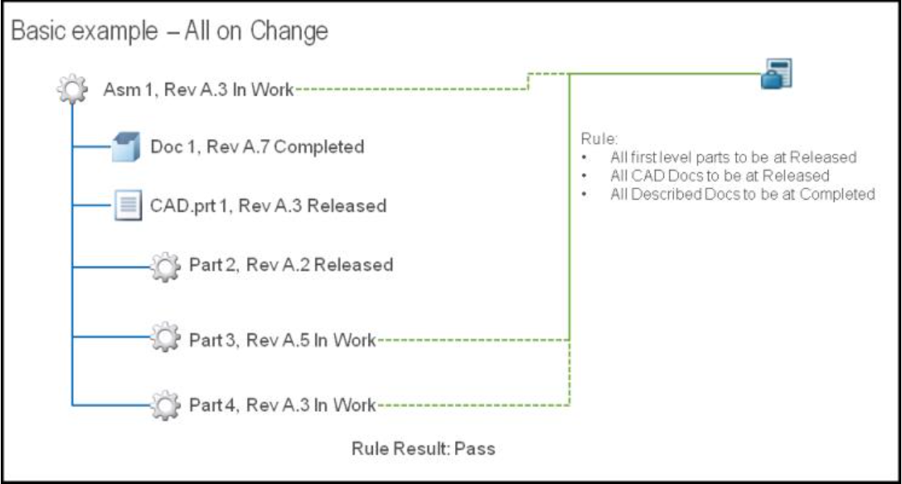

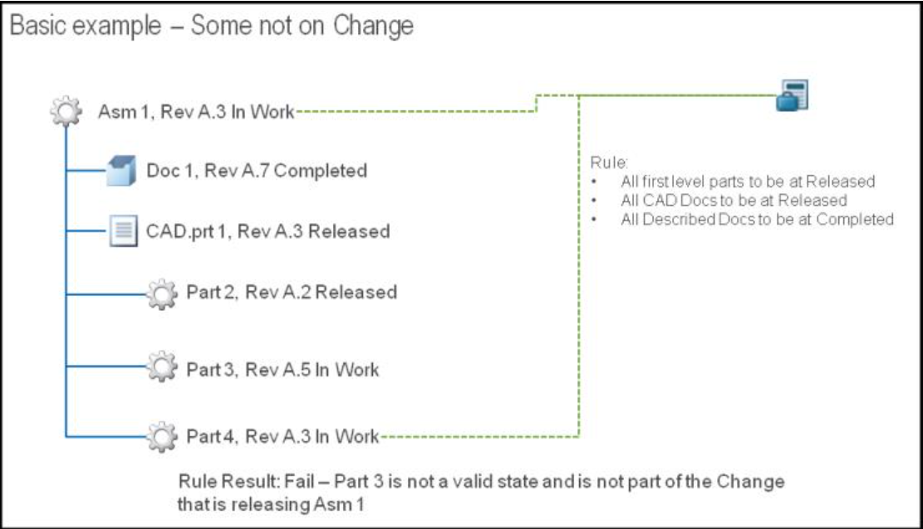

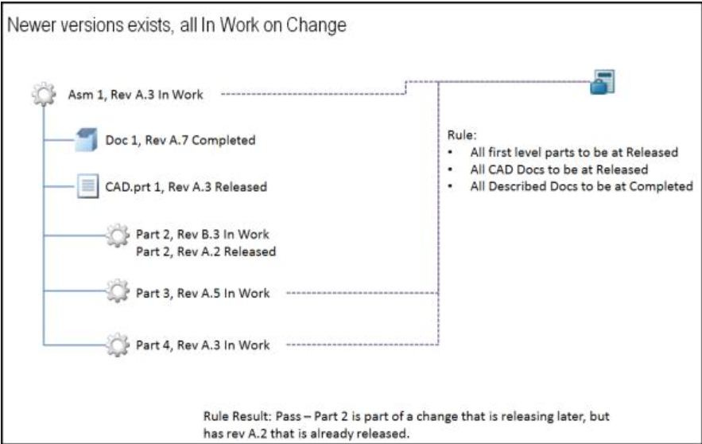

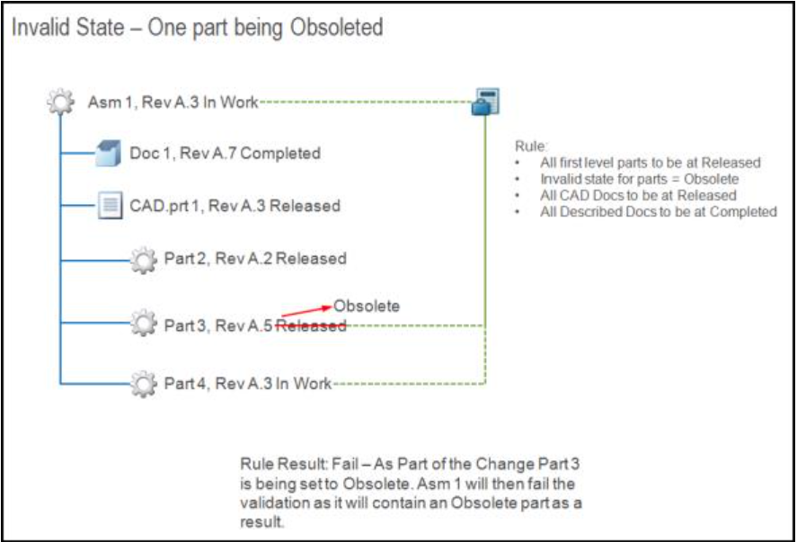

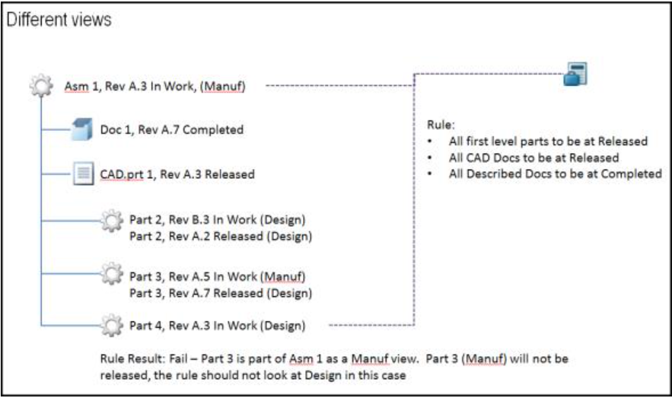

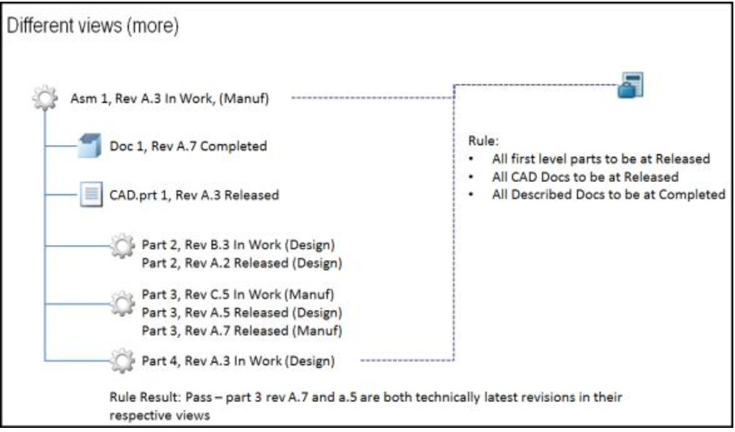

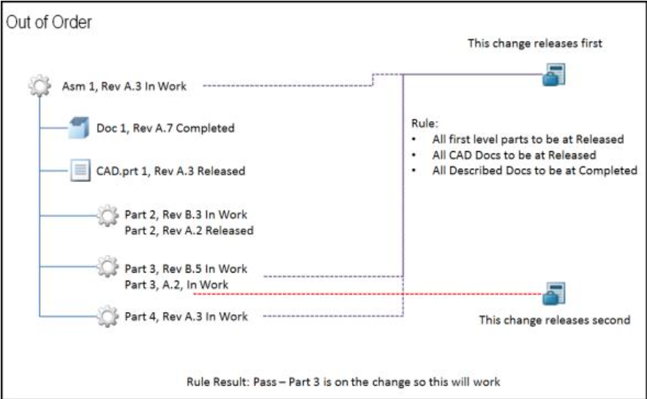

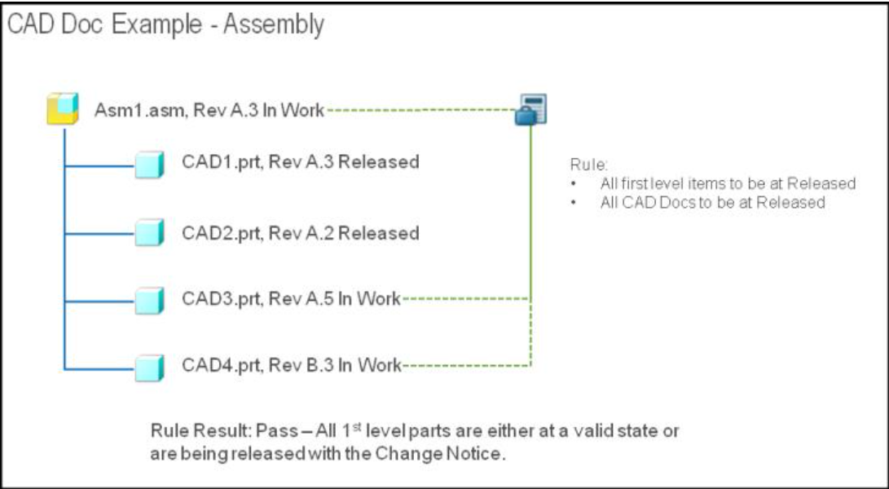

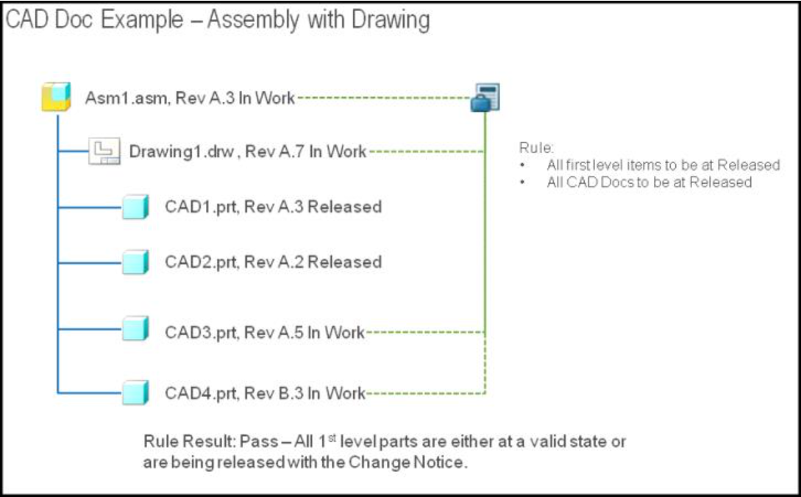

Example
Suppose you need to change an assembly that has many child parts. However, before you change the assembly, you want to ensure that all of the children are in the RELEASED state, or will be in the RELEASED state as a result of this change. You also want to ensure that all of the child parts are up to date, so you want to check that none of the child parts have become OBSOLETE. In order to configure this, you could create the following business rule objects.

Business rule set:
<?xml version="1.0" encoding="UTF-8" ?>
<!DOCTYPE BusinessRuleSet SYSTEM "standardX20.dtd">
<BusinessRuleSet>
<ObjectID><localId>wt.businessRules.BusinessRuleSet:45347</localId>
</ObjectID>
<objectContainerPath>/wt.inf.container.OrgContainer=
BusinessRulesTestOrganization/wt.pdmlink.PDMLinkProduct=
BusinessRulesTestProduct</objectContainerPath>
<key>CHANGEABLE_PRE_RELEASE</key>
<name>Test_Changeable_ReleaseRuleSet</name>
<description>To test basic Attribute RuleSet Validation</description>
<enabled>true</enabled>
<overridable>true</overridable>
<updateIfExists>true</updateIfExists>
</BusinessRuleSet>
Business rule:
<?xml version="1.0" encoding="UTF-8" ?>
<!DOCTYPE BusinessRule SYSTEM "standardX20.dtd">
<BusinessRule>
<ObjectID><localId>wt.businessRules.BusinessRule:158927</localId>
</ObjectID>
<objectContainerPath>/wt.inf.container.OrgContainer=
BusinessRulesTestOrganization/wt.pdmlink.PDMLinkProduct=
BusinessRulesTestProduct</objectContainerPath>
<key>BOM_RELEASE_RULE_RELEASED_STATE</key>
<selector>BOM_RELEASE_RULE</selector>
<name>Test BOM release Rule</name>
<description>Test BOM release Rule RELEASED State</description>
<enabled>true</enabled>
<updateIfExists>true</updateIfExists>
<configs>
<config name="targetState" value="RELEASED"></config>
<config name="validDependentState" value="RELEASED"></config>
<config name="invalidDependentState" value="OBSOLETE"></config>
<config name="checkPredecessorRevisions" value="true"></config>
<config name="collectionComponentID" value=
"COLLECT_ITEMS_FOR_BOM_RELEASE_RULE"></config>
</configs>
</BusinessRule>
Business rule link:
<?xml version="1.0" encoding="UTF-8" ?>
<!DOCTYPE BusinessRuleLink SYSTEM "standardX20.dtd">
<BusinessRuleLink>
<ObjectID><localId>wt.businessRules.BusinessRuleLink:168920</localId>
</ObjectID>
<ruleSet><ObjectReference><localId>wt.businessRules.BusinessRuleSet:45347
</localId></ObjectReference></ruleSet>
<rule><ObjectReference><localId>wt.businessRules.BusinessRule:158927
</localId></ObjectReference></rule>
<blockNumber>1</blockNumber>
<updateIfExists>true</updateIfExists>
</BusinessRuleLink>

Available Business Rule Set
The CHANGEABLE_PRE_RELEASE business rule set is delivered with your system. It includes:
• Checkout Rule
• Release Target Rule
The change notice workflow executes the CHANGEABLE_PRE_RELEASE business rule set in the Audit Change Notice and Resolve Release Conflicts conditional workflow objects.

If you have customized workflows or have updated your system from a previous version of Windchill, you must manually configure the workflows to include the business rule set.

You can find the zipped changeable prerelease file in the following location:
<Windchill>\loadFiles\ixbImport\ChangePreReleaseBusinessRulesObjects.zip

Administration of Business Rules

The system or business administrator has the following duties:
• Configure the appropriate business rules for use
• Maintain the business rules
• Diagnose and manage issues with rules

Rule Sets Table
The Rule Sets table contains the loaded business rule sets and rules for a particular context.
The following actions are available on the Rule Sets table

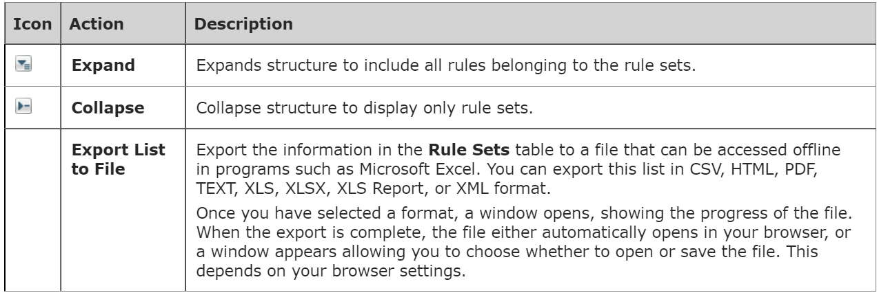

Defining New Business Rules

You can define your own business rules by creating and loading XML files using the businessRules.dtd definition.
The following example shows how to define a business rule (wt.businessRules.BusinessRule:45346), a business rule set (wt.businessRules.BusinessRuleSet:45345), and a business rule link (wt.businessRules.BusinessRuleLink:356747) that associates the business rule with the business rule set.

The numbers in the example above are IDs used in the XML to differentiate each object.

1. Define the business rule.
<?xml version="1.0" encoding="UTF-8" ?>
<!DOCTYPE BusinessRule SYSTEM "standardX20.dtd">
<BusinessRule>
<ObjectID><localId>wt.businessRules.BusinessRule:45346</localId>
</ObjectID>
<objectContainerPath>/</objectContainerPath>
<key>IXBBusinessRule1_key</key>
<name>
com.ptc.windchill.enterprise.change2.change2ClientResource:
CHECK_OUT_VALIDATOR_RULE_NAME</name>
<description>
com.ptc.windchill.enterprise.change2.change2ClientResource:
CHECK_OUT_VALIDATOR_RULE_DESC</description>
<enabled>true</enabled>
<configs>
<config name="key1" value="value1"></config>
<config name="key2" value="value1"></config>
<config name="key1" value="value2"></config>
</configs>
</BusinessRule>

2. Define the business rule set.
<?xml version="1.0" encoding="UTF-8" ?>
<!DOCTYPE BusinessRuleSet SYSTEM "standardX20.dtd">
<BusinessRuleSet>
<ObjectID><localId>wt.businessRules.BusinessRuleSet:45345</localId>
</ObjectID>
<objectContainerPath>/wt.inf.container.OrgContainer=PTC/wt.pdmlink.
PDMLinkProduct=GOLF_CART>
</objectContainerPath>
<key>IXBBusinessRuleSet1_key</key>
<name>
com.ptc.windchill.enterprise.change2.change2ClientResource:
CHANGE_PRE_RELEASE_RULESET_NAME</name>
<description>
com.ptc.windchill.enterprise.change2.change2ClientResource:
CHANGE_PRE_RELEASE_RULESET_DESC</description>
<enabled>true</enabled>
<overridable>true</overridable>
</BusinessRuleSet>

3. Define the business rule link.
<?xml version="1.0" encoding="UTF-8" ?>
<!DOCTYPE BusinessRuleLink SYSTEM "standardX20.dtd">
<BusinessRuleLink>
<ObjectID><localId>wt.businessRules.BusinessRuleLink:356747</localId>
</ObjectID>
<ruleSet><ObjectReference><localId>wt.businessRules.BusinessRuleSet:
45345</localId></ObjectReference></ruleSet>
<rule><ObjectReference><localId>wt.businessRules.BusinessRule:45346
</localId></ObjectReference></rule>
<blockNumber>10</blockNumber>
</BusinessRuleLink>

4. Load the XML files. For more information, see Loading Business Rules Objects.

Updating Existing Business Rules

You can update existing rules by adding the updateIfExists attribute to the business rules rule sets load files and setting the value of the attribute to true. If the attribute is not in the load file or the attribute is set to false, you cannot update existing rules and you get an error when you attempt to reload the load files.

Because the key and context creates the BusinessRule object uniqueness, you cannot update both even if the updateIfExists attribute is set to true.
Here is an example of how to enable updating:
<?xml version="1.0" encoding="UTF-8" ?>
<!DOCTYPE BusinessRule SYSTEM "standardX20.dtd">
<BusinessRule>
...
<updateIfExists>true</updateIfExists>
...
</BusinessRule>

Loading Business Rules Objects

After defining new business rules, or updating existing rules, use this procedure to load the business rules:

1. Add the load files to a zip file. For example, add the BusinessRulesObjects in a zip file such as:
<windchill>/loadFiles/ixbImport/BusinessRuleObjects.zip.

The zip file must be located in a folder path within the <windchill> directory.
2. Create the XML load file to load the generated zip file created in step 1.
Here is an example:
<?xml version="1.0"?>
<!DOCTYPE NmLoader SYSTEM "standardX20.dtd">
<NmLoader>
<csvExecuteImport handler="wt.load.LoadImport.executeImport">
<csvimportFilename>loadFiles/ixbImport/businessRulesObjects.zip
</csvimportFilename>
</csvExecuteImport>
</NmLoader>

3. Using a windchill shell, execute the following load command to load the business rules objects.
windchill wt.load.LoadFromFile -d <PATH>\loadFileName
where loadFileName refers to the file created in step 2. Executing the command stores the business rule objects in the database, ready to be configured.

Deleting Business Rule Objects

You can delete existing business rule objects by using the DeleteBusinessRuleObjects command line utility.
To delete a business rule or business rule set, run the following command:
windchill wt.businessRules.DeleteBusinessRuleObjects “typeOfObjectToDelete:
key:containerPath”
To delete a business rule link, both the business rule set and the business rule need to be specified:
windchill wt.businessRules.DeleteBusinessRuleObjects "typeOfObjectToDelete:
Key:containerPath:Key:containerPath"

Argument Name | Description | Examples
typeOfObjectToDelete | The type of object to delete | BusinessRuleBusinessRuleSet BusinessRuleLink
Key | The unique key of the object to delete | CHECKOUT_RULE CHANGEABLE_PRE_RELEASE
containerPath | The context path of the object | /wt.inf.container.OrgContainer=PTC/wt.pdmlink.PDMLinkProduct=GOLF_CART
The argument for the object to delete must be in quotes since context paths may contain spaces.

If a business rule or business rule set is deleted, any link to which the object was associated is also deleted. You can specify one or more objects, separated by a space.
The following table shows examples of deleting business rule objects:

Deleting a business rule | windchill wt.businessRules.DeleteBusinessRuleObjects  "BusinessRule:keyToDelete:/wt.inf.container.OrgContainer=Org  Name/wt.pdmlink.PDMLinkProduct=Product Name"
Deleting two business rule sets | windchill wt.businessRules.DeleteBusinessRuleObjects  "BusinessRuleSet:keyToDelete:/wt.inf.container.OrgContainer=  Org Name/wt.pdmlink.PDMLinkProduct=Product Name"  "BusinessRuleSet:anotherKey:/wt.inf.container.OrgContainer=  Org Name/wt.pdmlink.PDMLinkProduct=Product Name"
Deleting a business rule link | windchill wt.businessRules.DeleteBusinessRuleObjects  "BusinessRuleLink:businessRuleSetKey:/wt.inf.container.  OrgContainer=Org Name/wt.pdmlink.PDMLinkProduct=Product  Name:businessRuleKey:/wt.inf.container.OrgContainer=Org  Name/wt.pdmlink.PDMLinkProduct=Product Name"

Viewing Rule Conflicts

The Rule Conflicts table allows you to see the business rules that have been violated. The lists in the table contain only those objects to which you have access.

There are two views by which you can view rule conflicts: Group by Object and Group by Rule.

There are two views by which you can view rule conflicts: Group by Object and Group by Rule.
The action available on the Rule Conflicts table in either view is the Export List to File action. The action allows you to export the information in the Rule Conflicts table to a file that can be accessed offline in programs such as Microsoft Excel. You can export this list in CSV, HTML, PDF, TEXT, XLS, XLSX, XLS Report, or XML format. Once you have selected a format, a window opens, showing the progress of the file. When the export is complete, the file either automatically opens in your browser, or a window appears allowing you to choose whether to open or save the file. This depends on your browser settings.

Group by Object View
The Group by Object view lists the objects that violate a rule and includes the following columns: type icon, number, checkout status, name, version, organization ID, and conflicts. Clicking the object number link or the information icon opens the information page of the object.

Group by Rule View
The Group by Rule view lists the rules that are violated includes the following columns: rule name, checkout status, type icon, identity, and conflicts. Clicking the object identity link or the information icon opens the information page of the object. The number in parentheses after the rule name indicates the total number of objects that fail for the rule. The list contains only those objects to which you have access.

Business Rules Execution

The business rules engine executes registered rules in a business rule set and returns validation results.
The phases of the execution of a business rule set include:
- Retrieve the specified objects to be validated
- Retrieve the business rule set
- Generate and execute a plan for the business rule sets
- Report the results
See the Windchill Customization Guide for more information about these steps.

Calling the Business Rules Engine

The default change notice workflow demonstrates how to call the business rules engine from a workflow. The default change notice workflow comes with two conditionals that call the business rules engine: the Audit Change Notice and the Resolve Release Conflicts tasks shows the results of the conditionals that invoke the business rules engine. The Audit Change Notice task shows the rule conflicts, allowing you to proceed. The Resolve Release Conflicts task shows the rule conflicts that must be corrected before you proceed.

If you want to be able to bypass business rule conflicts, see Example for Bypassing Business Rules Conflicts.

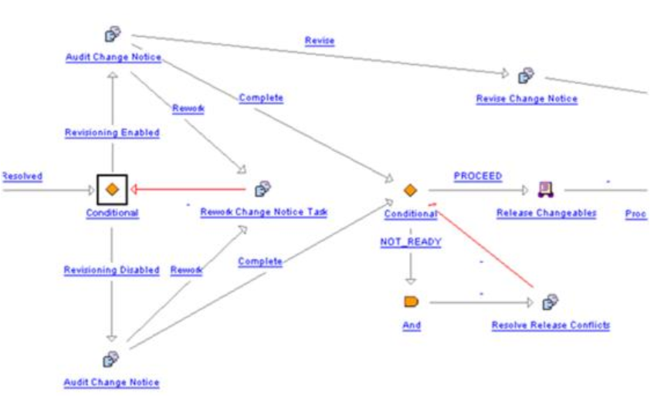

The business rules engine retrieves the set of business rules given the business rule set unique key and the context reference of the objects. The business rules are executed against the objects. See the Javadoc for supported APIs.

Business Rule Sets Results

If the validation results are not successful, a View Conflicts link appears on the Audit Change Notice or Resolve Release Conflicts task pages. To show the results of the business rule sets on a change notice, open the task. Click the View Conflicts link to determine the rules that failed and why.
If there is no View Conflicts link, all business rules were validated.

If you have customized workflows or have updated your system from a previous version of Windchill, you must manually configure the workflows to include the business rule set.

To show the results of the business rule sets on a workflow task, you need to create a workflow variable named businessRulesResultSetGlobal and set the type to serialized string of the validation result set. Then, for any task that you want to show the results in, create a new workflow variable on that task named businessRulesResultSet. On the Initialize From field, set the value to be businessRulesResultSetGlobal, and the Copy Into field should be businessRulesResultSet. This copies the global value into the current task value so that history can be maintained on the workflow task results. Use BusinessRulesHelper.serialize to create a serialized string of the validation result set. When the businessRulesResultSetGlobal is set, a View Conflicts link displays as part of the subject in the workflow task. To see the report of evaluated business rule sets, click the link.

For more information, see Viewing Rule Conflicts
The Audit Change Notice task presents the errors, but allows you to continue.

Rule Set Hierarchy

The context hierarchy defines the site context as the top-level parent context and each organization context created as a child of the site context. Then, the application contexts created become children of the organization context under which they are created.

The following table shows that the context of the object determines the adherence of the rule set:

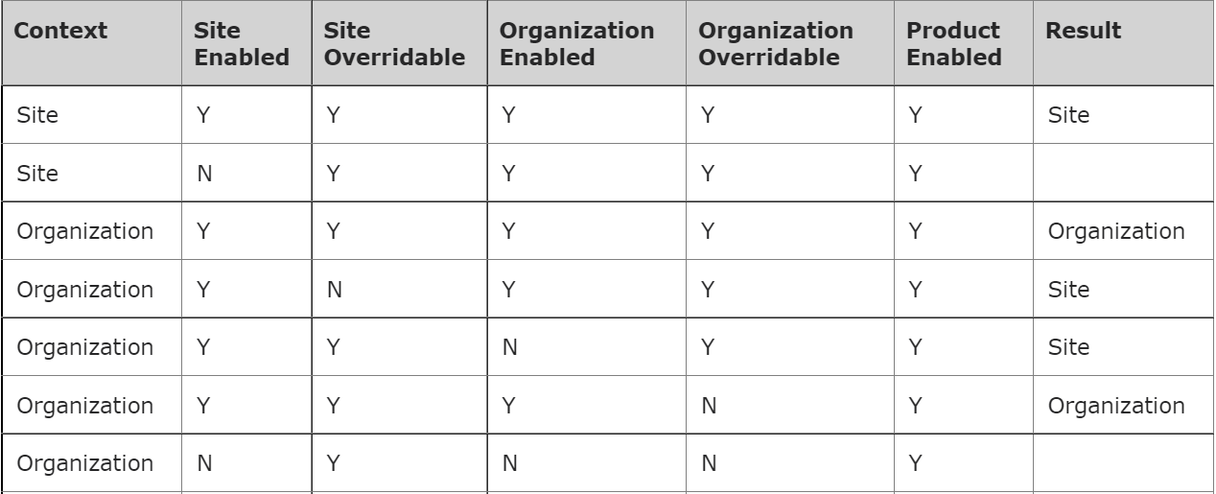
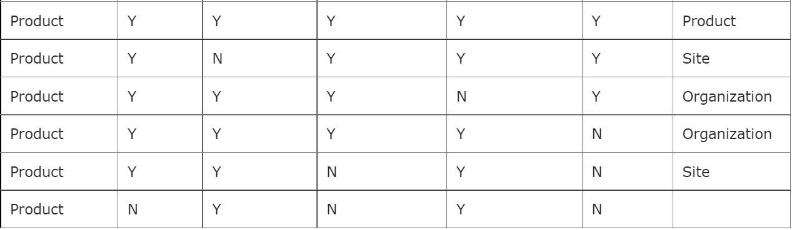

Example of Multiple Rules, Rule Sets, and Relationships

Suppose you have a need to configure rules against multiple products and multiple relationships. Consider the following example:

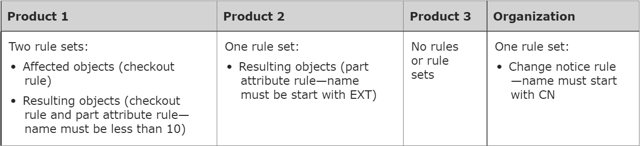

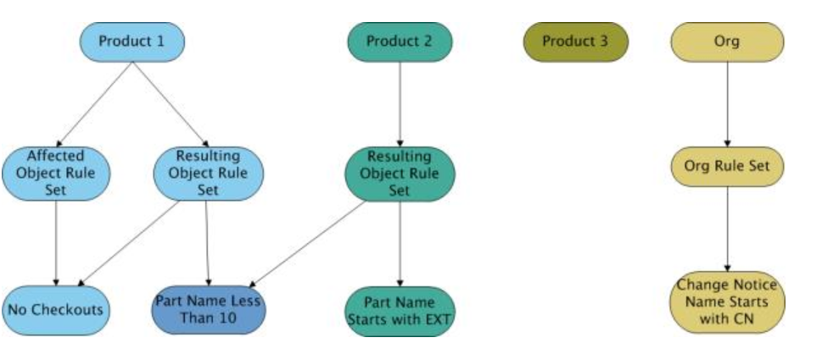

After all the rules are created, you could configure the workflow to use these rule sets by using code such as the following:
com.ptc.core.businessRules.engine.BusinessRuleSetBean[] ruleSetBeans = new
com.ptc.core.businessRules.engine.BusinessRuleSetBean[] {
com.ptc.core.businessRules.engine.BusinessRuleSetBean.
newBusinessRuleSetBean ("CNOrgRuleSet", com.ptc.core.businessRules.engine.
BusinessRuleSetBean.PRIMARY_BUSINESS_OBJECT),
com.ptc.core.businessRules.engine.BusinessRuleSetBean.
newBusinessRuleSetBean("AffectedPartProdRuleSet", wt.change2.
AffectedActivityData.class.getName()),
com.ptc.core.businessRules.engine.BusinessRuleSetBean.newBusinessRuleSetBean
("ResultingPartProdRuleSet", wt.change2.ChangeRecord2.class.getName())
};
businessRulesResultSetGlobal = "";
preReleaseConflictsMsg = "";
com.ptc.core.businessRules.validation.RuleValidationResultSet
resultSet = wt.businessRules.BusinessRulesHelper.engine.execute
(primaryBusinessObject, ruleSetBeans );

Examples:
• If you had a part in Product 1 that was a resulting object, the part would have to have a part name less than 10 characters, and it could not be checked out.
• If you had a document in Product 2 that was a resulting object, then there are no rules for it because there are only rules for parts.

Example for Bypassing Business Rule Conflicts

You might want to show some or all business rule failures, but not prevent the workflow from continuing or completing. Create two unique business rule sets, one in which the rules are required for continuing or completing the process and another in which failures of rules are reported but are not required to complete the process. Having two separate business rule sets allow you to configure a workflow process to call either rule set at different points in the workflow process.

The following example shows how to configure a set of rules that are required to proceed and a second set of rules that are not required. Assume that you want to check that certain attributes are filled in (in this case, Material). If the attributes are blank, the process will continue; however, the release target rule must pass.

1. Create a nonrequired business rule set for attribute checks.
<?xml version="1.0" encoding="UTF-8" ?>
<!DOCTYPE BusinessRuleSet SYSTEM "standardX20.dtd">
<BusinessRuleSet>
<ObjectID><localId>wt.businessRules.BusinessRuleSet:10001</localId>
</ObjectID>
<objectContainerPath>/wt.inf.container.OrgContainer=
Demo Organization/wt.pdmlink.PDMLinkProduct=Example1TestProduct
</objectContainerPath>
<key>EXAMPLE1_NON_REQUIRED_ATTRIBUTE_RULE_SET</key>
<name>EXAMPLE1_NON_REQUIRED_ATTRIBUTE_RULE_SET</name>
<description>EXAMPLE1_NON_REQUIRED_ATTRIBUTE_RULE_SET</description>
<enabled>true</enabled>
<overridable>true</overridable>
<updateIfExists>true</updateIfExists>
</BusinessRuleSet>
2. Create an attribute rule for Material.
<?xml version="1.0" encoding="UTF-8" ?>
<!DOCTYPE BusinessRule SYSTEM "standardX20.dtd">
<BusinessRule>
<ObjectID><localId>wt.businessRules.BusinessRule:10002</localId>
</ObjectID>
<objectContainerPath>/wt.inf.container.OrgContainer=
Demo Organization/wt.pdmlink.PDMLinkProduct=Example1TestProduct
</objectContainerPath>
<key>EXAMPLE1_ATTRIBUTE_RULE</key>
<selector>ATTRIBUTE_RULE</selector>
<name>Example 1 Attribute Rule</name>
<description>Example 1 Attribute Rule</description>
<enabled>true</enabled>
<updateIfExists>true</updateIfExists>
<configs>
<config name="objectType" value="com.ptc.Part"></config>
<config name="Material" value="SET"></config>
</configs>
</BusinessRule>
3. Create a link for the attribute rule and the nonrequired rule set.
<?xml version="1.0" encoding="UTF-8" ?>
<!DOCTYPE BusinessRule SYSTEM "standardX20.dtd">
<BusinessRuleLink>
<ObjectID><localId>wt.businessRules.BusinessRuleLink:10003</localId>
</ObjectID>
<ruleSet><ObjectReference><localId>wt.businessRules.BusinessRuleSet:10001
</localId></ObjectReference></ruleSet>
<rule><ObjectReference><localId>wt.businessRules.BusinessRule:10002
</localId></ObjectReference></rule>
<blockNumber>1</blockNumber>
<updateIfExists>true</updateIfExists>
</BusinessRuleLink>
4. Create a required business rule set for release target rule.
<?xml version="1.0" encoding="UTF-8" ?>
<!DOCTYPE BusinessRuleSet SYSTEM "standardX20.dtd">
<BusinessRuleSet>
<ObjectID><localId>wt.businessRules.BusinessRuleSet:20001</localId>
</ObjectID>
<objectContainerPath>/wt.inf.container.OrgContainer=Demo Organization
/wt.pdmlink.PDMLinkProduct=Example1TestProduct</objectContainerPath>
<key>EXAMPLE1_RELEASE_RULE_SET</key>
<name>Example1_ReleaseRuleSet</name>
<enabled>true</enabled>
<description>Example1_ReleaseRuleSet</description>
<overridable>true</overridable>
<updateIfExists>true</updateIfExists>
</BusinessRuleSet>
5. Reload the site release target rule.
<?xml version="1.0" encoding="UTF-8" ?>
<!DOCTYPE BusinessRule SYSTEM "standardX20.dtd">
<BusinessRule>
<ObjectID><localId>wt.businessRules.BusinessRule:20002</localId>
</ObjectID>
<key>RELEASE_TARGET</key>
<selector>RELEASE_TARGET</selector>
<name>com.ptc.windchill.enterprise.change2.change2ClientResource:
RELEASE_TARGET_RULE_NAME</name>
<description>com.ptc.windchill.enterprise.change2.
change2ClientResource:RELEASE_TARGET_RULE_DESC</description>
<enabled>true</enabled>
<updateIfExists>true</updateIfExists>
</BusinessRule>
6. Create the link for the target rule and required rule set.
<?xml version="1.0" encoding="UTF-8" ?>
<!DOCTYPE BusinessRuleLink SYSTEM "standardX20.dtd">
<BusinessRuleLink>
<ObjectID><localId>wt.businessRules.BusinessRuleLink:20003</localId>
</ObjectID>
<ruleSet><ObjectReference><localId>wt.businessRules.BusinessRuleSet:
20001</localId></ObjectReference></ruleSet>
<rule><ObjectReference><localId>wt.businessRules.BusinessRule:20002
</localId></ObjectReference></rule>
<blockNumber>1</blockNumber>
<updateIfExists>true</updateIfExists>
</BusinessRuleLink>
7. Execute all required and nonrequired business rule sets. To display all required and nonrequired rule conflicts, update the Audit Change Notice workflow task conditional to use both rule sets EXAMPLE1_RELEASE_RULE_SET and EXAMPLE1_NON_REQUIRED_ATTRIBUTE_RULE_SET.

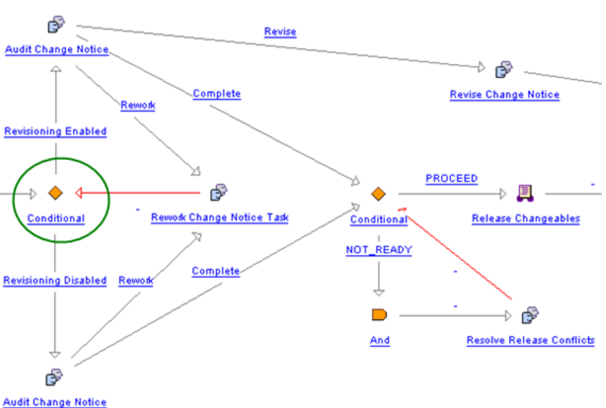

if (wt.change2.ChangeHelper2.isTrackingChange((wt.inf.container.
WTContained)primaryBusinessObject)) {
result = "Revisioning Enabled";
}else {
result = "Revisioning Disabled";
com.ptc.core.businessRules.engine.BusinessRuleSetBean[] beans = new
com.ptc.core.businessRules.engine.BusinessRuleSetBean[] {
// Configure to call non-required rule set
com.ptc.core.businessRules.engine.BusinessRuleSetBean.newBusinessRuleSetBean
("EXAMPLE1_NON_REQUIRED_ATTRIBUTE_RULE_SET", "wt.change2.ChangeRecord2"),
// Configure to call required rule set
com.ptc.core.businessRules.engine.BusinessRuleSetBean.newBusinessRuleSetBean
("EXAMPLE1_RELEASE_RULE_SET", "wt.change2.ChangeRecord2")
};
}
com.ptc.core.businessRules.validation.RuleValidationResultSet resultSet =
wt.businessRules.BusinessRulesHelper.engine.execute(primaryBusinessObject, beans);
if ( resultSet.hasResultsByStatus(com.ptc.core.businessRules.validation.
RuleValidationStatus.FAILURE)) {
businessRulesResultSetGlobal = wt.businessRules.BusinessRulesHelper.
serialize(resultSet);
preReleaseConflictsMsg = new wt.util.WTMessage("com.ptc.windchill.
enterprise.change2.change2ClientResource", com.ptc.windchill.enterprise.
change2.change2ClientResource.BUSINESS_RULES_PRERELEASE_VALIDATION_MSG,
null).getLocalizedMessage();
preReleaseConflictsMsg = preReleaseConflictsMsg + "\n" + resultSet.
getFailedRulesMessage(java.util.Locale.getDefault());
}

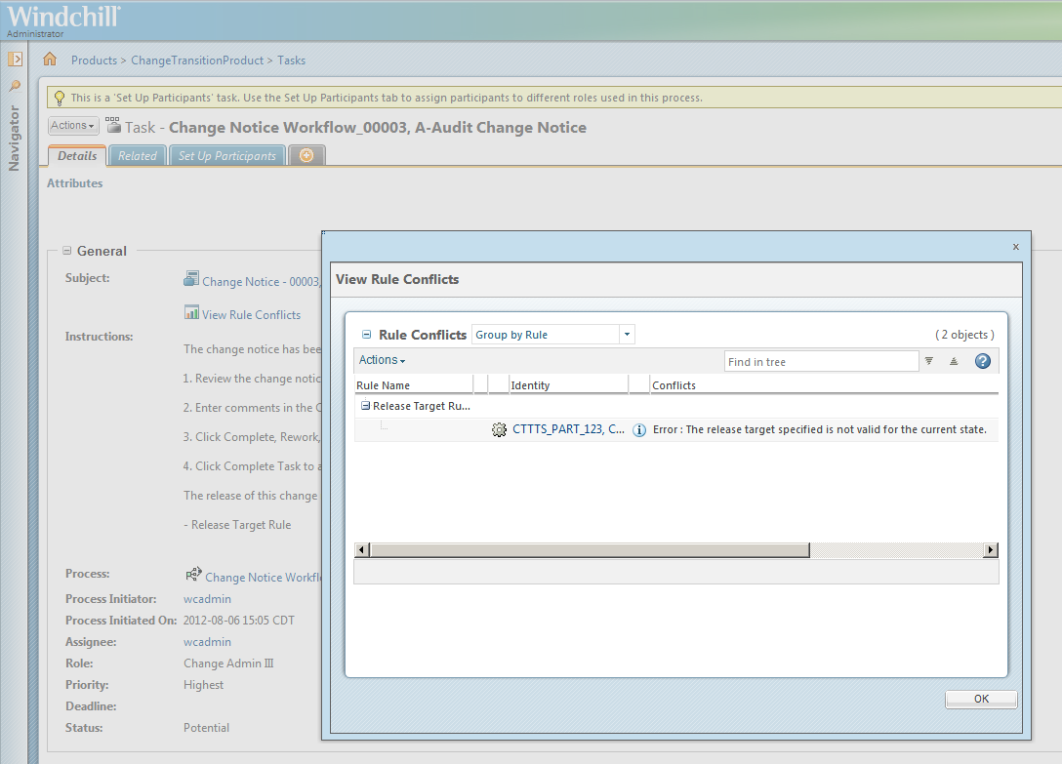

8. Execute the required business rule sets. In order to prevent the change notice workflow process for proceeding for the required business rules, update the conditional to use only the required rule set EXAMPLE1_RELEASE_RULE_SET for the Resolve Release Conflicts workflow task.
result = "NOT_READY";
com.ptc.core.businessRules.engine.BusinessRuleSetBean[] beans = new
com.ptc.core.businessRules.engine.BusinessRuleSetBean[] {
// Configure to call required rule set only
com.ptc.core.businessRules.engine.BusinessRuleSetBean.
newBusinessRuleSetBean("EXAMPLE1_RELEASE_RULE_SET",
"wt.change2.ChangeRecord2")
};
com.ptc.core.businessRules.validation.RuleValidationResultSet
resultSet = wt.businessRules.BusinessRulesHelper.engine.execute
(primaryBusinessObject, beans);
if ( !resultSet.hasResultsByStatus(com.ptc.core.businessRules.
validation.RuleValidationStatus.FAILURE)) {
result = "PROCEED";
} else {
businessRulesResultSetGlobal = wt.businessRules.BusinessRulesHelper.
serialize(resultSet);
preReleaseConflictsMsg = new wt.util.WTMessage("com.ptc.windchill.
enterprise.change2.change2ClientResource", com.ptc.windchill.enterprise.
change2.change2ClientResource.BUSINESS_RULES_PRERELEASE_VALIDATION_MSG,
null).getLocalizedMessage();
preReleaseConflictsMsg = preReleaseConflictsMsg + "\n" + resultSet.
getFailedRulesMessage(java.util.Locale.getDefault());
}
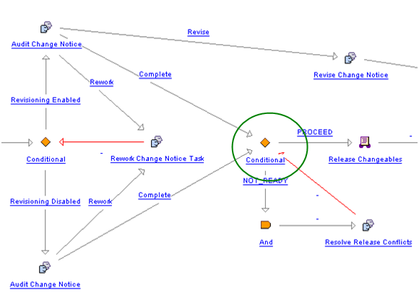
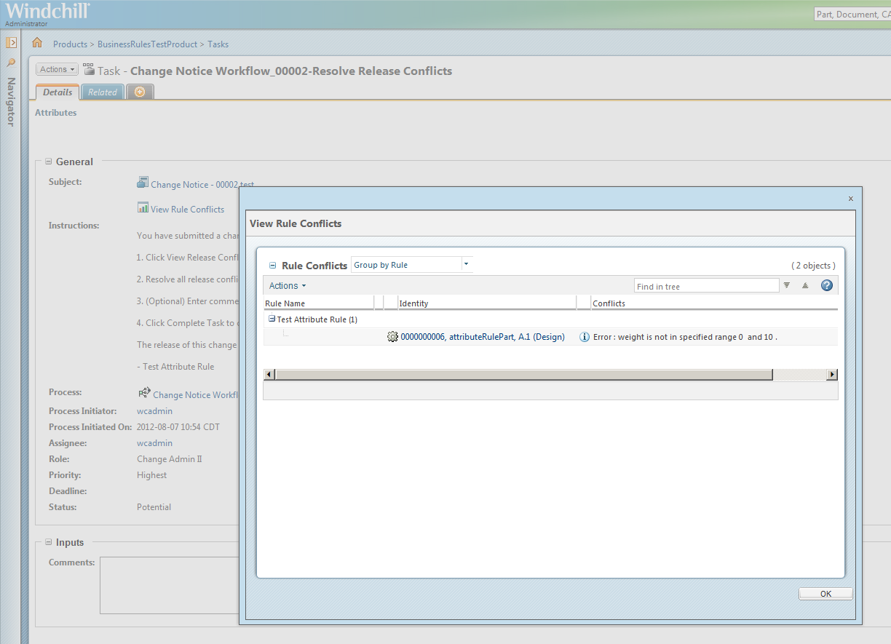

The Resolve Release Conflicts workflow task continues to regenerate the task until all conflicts have been resolved.

Troubleshooting Configuration Issues
To help you diagnose unexpected results, enable the following loggers on the method server. To enable the logging, follow these steps:
1. Navigate to \<windchill>\codebase\WEB-INF
2. Open log4jMethodServer.properties with a text editor
3. Add the following lines:
◦ To view potential configuration issues, such as rules or rule sets not being found in a context:
logger.businessRules.name=com.ptc.core.businessRules.engine
logger.businessRules.level=WARN
◦ To view potential performance issues, such as execution time of a business rule validation:
logger.businessRules.name=com.ptc.core.businessRules.engine
logger.businessRules.level=TRACE
◦ To view what rules are invoked by the business rules framework, set the level to:
logger.businessRules.name=com.ptc.core.businessRules.engine
logger.businessRules.level=INFO
◦ To set the debug mode back to default, remove what was previously added or set the following:
logger.businessRules.name=com.ptc.core.businessRules.engine
logger.businessRules.level=ERROR
- Reboot the method server.

Business Rule Solution Elements
Element | Type | Package | Description
BusinessRuleSet | Java class | wt.businessRules | A BusinessRuleSet instance is the configuration used to navigate a set of business rules for a container.
BusinessRule | Java class | wt.businessRules | BusinessRule will hold the information about the rule to be executed. Each rule may have unique configuration requirements associated to it.
BusinessRuleLink | Java class | wt.businessRules | An ObjectToObject binary link holding the references to BusinessRuleSet and BusinessRule. Each BusinessRuleSet is associated to BusinessRules using BusinessRuleLinks.
BusinessRulesHelper | Java class | wt.businessRules | Helper for the business rules service and engine.
BusinessRulesEngine | Java class | com.ptc.core.businessRules.engine | The business rules engine will execute the validation of each business rule in order as defined by the execution plan set in the business rule set.
BusinessRuleSetBean | Java Class | com.ptc.core.businessRules.engine | Used to specify more than one business rule set and target collection relationship key at a time in order to generate an accumulation of results with one call to the business rule engine.
RuleValidationCriteria | Java Class | com.ptc.core.businessRules.validation | Contains information that is used by all business rules within a business rule set.
RuleValidation | Java Class | com.ptc.core.businessRules.validation | Interface for the business rule validators. Custom validators should implement this interface.
RuleValidationResult | Java Class | com.ptc.core.businessRules.validation | Contains one validation output per business rule. It contains a rule validation key to indicate the business rule that was executed. It will hold a validation status attribute to indicate if the business rule successfully passed the validation or not. The RuleValidationResult will also contain the target object, which links the result to a specific WTReference, and a list of feedback messages which contains text that could optionally be displayed in a report.
RuleValidationResultSet | Java Class | com.ptc.core.businessRules.validation | A set of RuleValidationResult objects.
BusinessRuleSetRelationshipDelegate | Java Class | com.ptc.core.businessRules.relationship | Used to get the seed objects for a primary business object that is to be evaluated for a particular business rule set. Relationship delegates are registered in service.properties. See the “Retrieval of Seed Objects” for more information on these delegates.

Business Rules Configuration and Execution
The business rules engine executes the registered rules in a business rule set and return validation results. The business rules engine retrieves the set of business rules given the specified business rule set unique keys and the container references from the seed objects. With the set of business rules, the engine executes them against the seed objects.

The following phases describe the execution of business rule sets by the business rules engine:
1. Retrieves the specified seed objects to be validated
2. Retrieves the business rule sets
3. Generates and executes an execution plan for the business rule sets
4. Reports of the results of the plan executed.

Business Rules Execution Flow

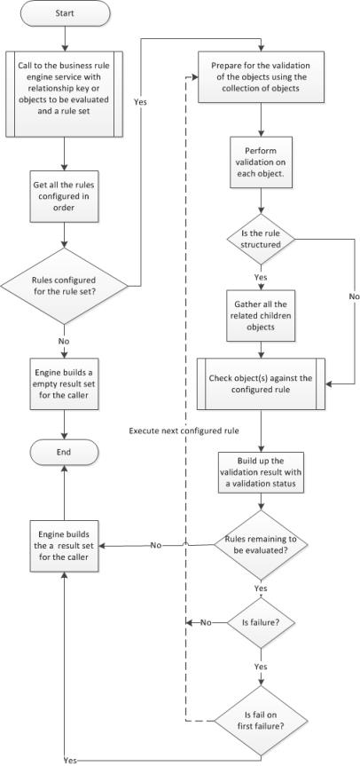

Calling the Business Rules Engine
There are examples in the default Change Notice and Promotion Request workflows that show how to call the business rules engine from a workflow. The default Change Notice workflow comes with two different conditionals which call the business rules engine. If there are any failures, the Audit Change Notice Task will show a link called “View Conflicts” on the task. The Audit Change Notice Task allows you to proceed without fixing the failures. Similarly, the Resolve Release Conflicts Task shows the conflicts if there are any. You must fix the problems before proceeding on this task.
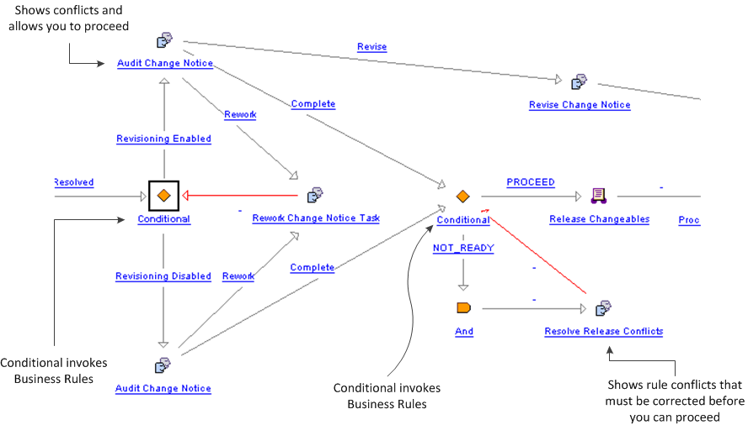

Here is another example of how you might want to set up a rework loop in the Promotion Request Approval Process. The Business rule is executed in the OR conditional. If it fails, then an email is sent and the Rework Promotion Request task appears.
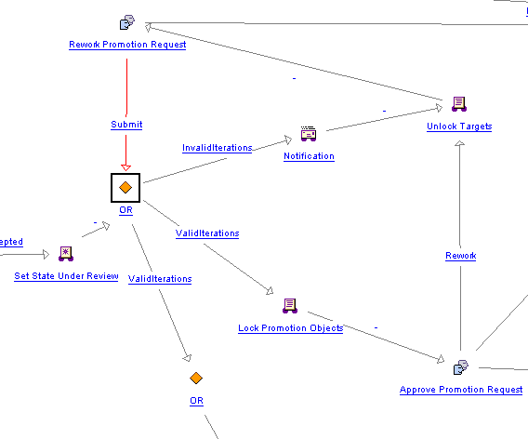
There are two supported APIs to execute business rule sets.

• BusinessRulesHelper.engine.execute(primaryBusinessObject, BusinessRuleSetBean[]) : RuleValidationResultSet
The second option allows for overriding the container for all objects regardless of the container that the seed objects are in. This API requires that the seed objects be specified up front and only supports executing one business rule set at a time.

• BusinessRulesHelper.engine.execute(“Business rule set”, RuleValidationCriteria) : RuleValidationResultSet
See Javadoc for more details.

Retrieval of Seed Objects

The relationship delegate is used to get the seed objects for a primary business object that is to be evaluated for a particular business rule set. All relationship delegates implement the RuleValidation interface.

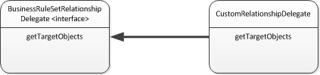

The selector is the relationship key which is used to look up the relationship delegate instance. The relationship key naming convention is to use the link class name but is not a requirement. Note that if the relationship delegate returns the links for the relationship, then the role B objects of the links will be used as the seed objects. The target link role can be optionally specified in the BusinessRuleSetBean or RuleValidationCriteria. See the Javadoc for BusinessRuleSetBean for details on how to specify the relationship for a business rule set and current supported relationship delegates.

The following table shows the default delegates that are provided in a standard Windchill installation:

Relationship | Relationship Delegate | Description
wt.change2.AffectedActivityData | com.ptc.core.businessRules.relationship.AffectedObjectsRelationshipDelegate | Gets the affected object links of the primary business object if it is a change notice or change task.
wt.change2.ReportedAgainst | com.ptc.core.businessRules.relationship.AffectedObjectsRelationshipDelegate | Gets the affected object links of the primary business object if it is a problem report or variance.
wt.change2.RelevantRequestData | com.ptc.core.businessRules.relationship.AffectedObjectsRelationshipDelegate | Gets the affected object links of the primary business object if it is a change request
wt.change2.ChangeRecord2 | com.ptc.core.businessRules.relationship.ResultingObjectsRelationshipDelegate | Gets the resulting object links of the primary business object if it is a change notice or change task.
wt.change2.IncludedIn2 | com.ptc.core.businessRules.relationship.IncludedInRelationshipDelegate | Gets the change tasks of the primary business object if it is a change notice or the change notice if the primary business object is a change task.
wt.maturity.MaturityBaseline | com.ptc.core.businessRules.relationship.MaturityBaselineObjectsRelationshipDelegate | Gets the baseline items of the primary business object if it is a promotion notice.
wt.maturity.PromotionSeed | com.ptc.core.businessRules.relationship.PromotionSeedObjectsRelationshipDelegate | Gets the promotion seeds of the primary business object if it is a promotion notice.
wt.maturity.PromotionTarget | com.ptc.core.businessRules.relationship.PromotionTargetObjectsRelationshipDelegate | Gets the promotion targets of the primary business object if it is a promotion notice.

Retrieval of the Business Rule Set Based on Container
The following information is required to obtain a business rule set from the system:
1. The unique key for a business rule set
2. The container reference of which the rules should be evaluated
The business rules engine will be responsible for acquiring the appropriate business rule set from the Windchill services. The business rule sets will be discovered using a hierarchical container lookup. Business rule sets that are not enabled will be ignored.
The following flow chart explains flow of the container look up for a rule set key and a container.

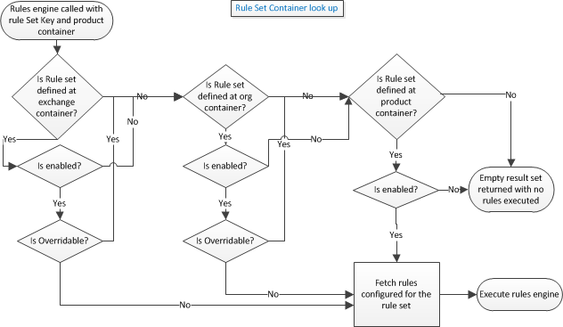

Executing the Business Rule Set Execution Plan
The generation of the execution plan of a business rule set will involve:
1. Creation of a specific RuleValidation instance based on the selector defined in the business rule.
2. The RuleValidation instance will be used to determine if the configuration of the business rule is valid using the isConfigurationValid method. If the configuration is not valid, the RuleValidation will be skipped for the business rule set execution plan and error will be logged.
3. For each business rule the RuleValidation instance is called with the following items:
a. Collection of objects that rules are to evaluate
b. Context specific criteria (such as the container reference) that may be used by a RuleValidation to configure its execution.
4. The RuleValidation instance is added to the execution plan.
All the business rule validators will implement the RuleValidation interface. A typical business rule will fall under two primary categories:
• Simple validation: The rules check is done on the business object itself or on the seed objects as configured by the relationship. An example could be checking for attribute validation or checking a life cycle state of the object prior to release.
• Structured validation: The rules may or may not be performed on the business objects but will include some validation checks on its associated objects like the children of the part or document. In this type of validation, typically more complex set of algorithm might be required to calculate the business validation rules and populate the validation result with appropriate flag. An example of structured validation rule is a validation check that makes sure that all resulting objects and all first level dependents are in the correct state.

The following are supported RuleValidation implementations that are provided with the default Windchill installation:

Business Rule Selector | RuleValidation | Description
CHECKOUT_RULE | com.ptc.core.businessRules.validation.CheckoutRuleValidator | Validates that objects are not checked out or checked out to a project.
RELEASE_TARGET | com.ptc.core.businessRules.validation.ReleaseTargetValidator | Ensures that all “Resulting Objects” are at an appropriate state for release and have an appropriate change management transition specified that is consistent with the assigned lifecycle transition rules.
ATTRIBUTE_RULE | com.ptc.core.businessRules.validation.AttributeRuleValidator | Validates that the specified attribute rule configuration for an object type is valid.
BOM_RELEASE_RULE | com.ptc.core.businessRules.validation.BOMReleaseRuleValidator | Ensures that all resulting objects are at an appropriate state and all their first level children are at an appropriate state.

As of the 11.0 release, the Promotion Request supports the Attribute Rule and the Check Out rule. The Change Notice supports any rule.

The instantiation of the RuleValidation will be based on the selector defined in the business rule. Application services will be used to lookup the implementing class for the defined selector. If no implementing class is defined, or the class fails to be instantiated an error will be logged.
Prior to executing any validation the engine will call the RuleValidation.isConfigurationValid which will determine if the business rule configuration is valid. This validation of the business rule configuration is also called when loading the business rule (see Creating Business Rules), but since it is possible to change the registered RuleValidation, validation of configuration is also called prior to executing the business rule validation.

TheRuleValidation initialization method called prepare is used to perform some initial preprocessing of the entire set of seed objects that will be validated against the set of business rules. This is to allow any pre-validation to occur within the Windchill server (example might be retrieving the lifecycle template which would be common to many of the items). It is best to call multi-object APIs from the RuleValidation.prepare method. It is advised not to use the RuleValidation.peformValidation method to perform multi-object calls.
If the method RuleValidation.isConfigurationValid returns true, the RuleValidation performValidation is called for each seed object. The seed object is passed inside the RuleValidationObject. The RuleValidationObject holds the target object (the seed object if it is not a link or the role A or role B if seed object is a link) and the link (if the seed object is a link). When the business rule is a structured type RuleValidation, the RuleValidationObject also contains the collected children and a map of the collected children to the links that they were collected with. The performValidation should always return a new RuleValidationResult that has a reference to the target object and not the link.

Business Rules Engine and Sequence Diagram
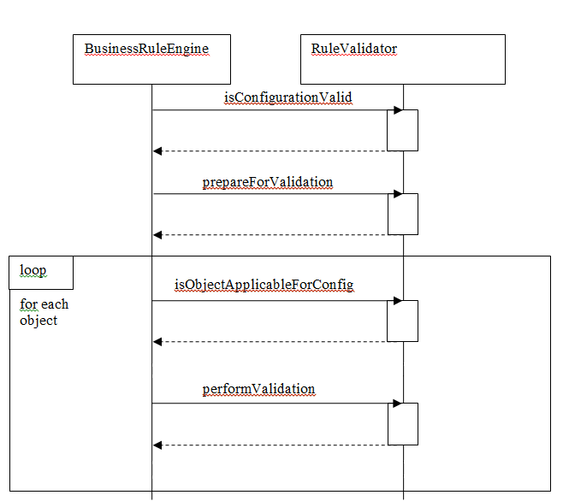

Business Rules Engine and Validation Interaction Diagram
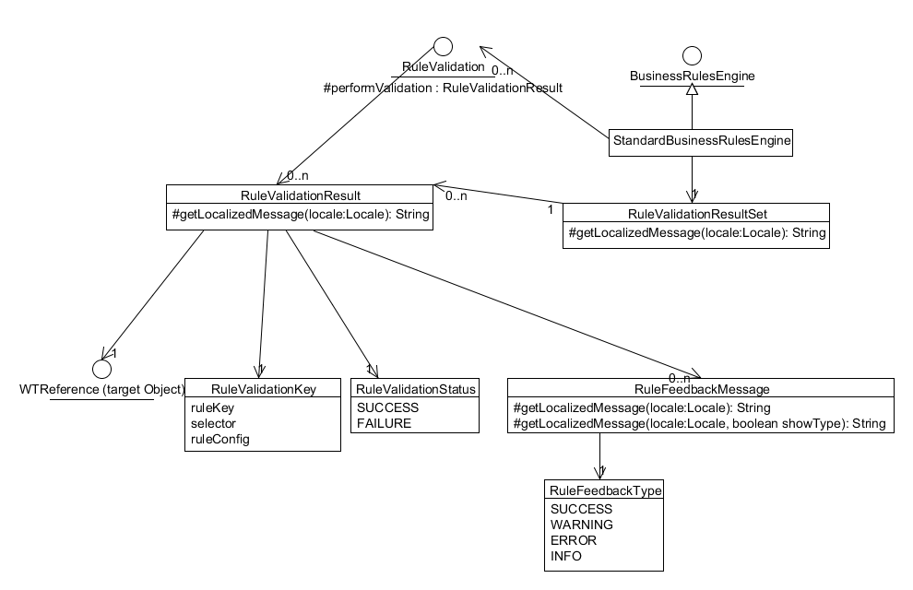
RuleValidation implementations are registered in service.properties. To create or override a RuleValidation implementation, add the following to a custom service.properties xconf file:
<Service context="default" name="com.ptc.core.businessRules.validation.
RuleValidation">
<Option serviceClass="com.ptc.core.businessRules.validation.
CheckoutRuleValidator"
selector="CHECKOUT_RULE"
cardinality="singleton"
requestor="null"/>
</Service>
When possible the cardinality of the RuleValidation should be set to “singleton” in order to reduce the number of instances of a particular RuleValidation implementation. The RuleValidationKey.processingMap can be used for storing pre-validation data in order to support thread safe processing of RuleValidation implementations when the cardinality is set to “singleton”.

Returning Results
The single validation result is generated for each target object that is evaluated is combined into an aggregated set of validation results (RuleValidationResultSet). The RuleValidationResultSet may contain only partial results if there are failures during the execution of the business rule set. The business rules engine may be invoked with an optional parameter indicating that the execution plan should abort further rule validation upon hitting a failure in a rule. Since the failure could occur in different rules for different objects, the execution plan will continue to the next seed object if the failure on error flag is set. The caller of the business rules engine must determine which mode the execution plan so execute in.

To show the results of the business rule sets on a workflow task, create a workflow variable named businessRulesResultSetGlobal and set the type to serialized string of the validation result set. Then, for any task that you want to show the results in, you should create a new workflow variable on that task named businessRulesResultSet. On the Initialize From field, set the value to be businessRulesResultSetGlobal and the Copy Into field should be businessRulesResultSet. This copies the global value into the current task value so that history can be maintained on the workflow task results. Use BusinessRulesHelper.serialize to create a serialized string of the validation result set. When the businessRulesResultSetGlobal is set a “View Conflicts” report link icon will display as part of the subject in the workflow task. To see the report of the evaluated business rule sets click on the “View Conflicts”.

Audit Change Notice with View Conflicts
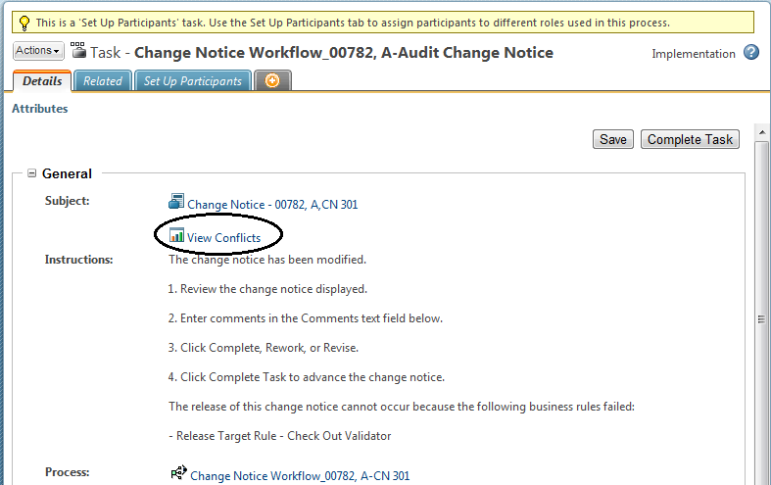

Business Rule Set Validation Report
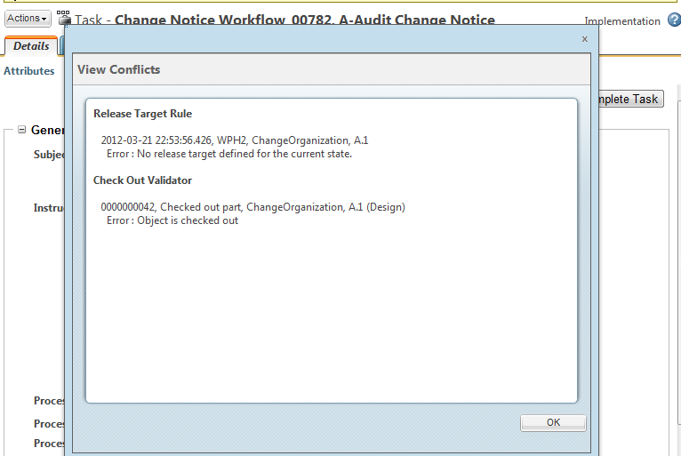

Sample Code

The following is an example of the workflow conditional syntax in the delivered Change Notice workflow template. The workflow conditional makes a call to the business rules engine for the CHANGEABLE_PRE_RELEASE business rule set. The CHANGEABLE_PRE_RELEASE business rule contains the CHECKOUT_RULE and RELEASE_TARGET business rules.

Routing Expression
result = "NOT_READY";
com.ptc.core.businessRules.engine.BusinessRuleSetBean[] ruleSetBeans =
new com.ptc.core.businessRules.engine.BusinessRuleSetBean[] {
com.ptc.core.businessRules.engine.BusinessRuleSetBean.
newBusinessRuleSetBean("CHANGEABLE_PRE_RELEASE", "wt.change2.ChangeRecord2")
};
//Invoke the business rule engine
com.ptc.core.businessRules.validation.RuleValidationResultSet resultSet =
wt.businessRules.BusinessRulesHelper.engine.execute(primaryBusinessObject,
ruleSetBeans);
if ( !resultSet.hasResultsByStatus(com.ptc.core.businessRules.validation.
RuleValidationStatus.FAILURE)) {
result = "PROCEED";
}
else {
//This line of code will start exception handling for the business
rules that failed
businessRulesResultSetGlobal = wt.businessRules.BusinessRulesHelper.
serialize(resultSet);
preReleaseConflictsMsg = new wt.util.WTMessage("com.ptc.windchill.
enterprise.change2.change2ClientResource", com.ptc.windchill.enterprise.
change2.change2ClientResource.BUSINESS_RULES_PRERELEASE_VALIDATION_MSG,
null).getLocalizedMessage();
preReleaseConflictsMsg = preReleaseConflictsMsg + "\n" + resultSet.
getFailedRulesMessage(java.util.Locale.getDefault());
}

Note that if the validation results are not successful, the attribute businessRulesResultSetGlobal is set to the serialized string of the validation result set. The “View Conflicts” report link will show up on the “Audit Change Notice” and “Resolve Release Conflicts” workflow task pages.

Loading Business Rule Objects

This section describes how to create load files for the business rule objects. While creating the business rules object, you need to use the IXB framework for loading the BusinessRules objects. The intended outcome is an XML output that follows a defined DTD for the business rules objects.

Prerequisite Knowledge
To perform this task, you need to have an understanding of the following:
• General knowledge of using DTD for creating XMLs
• Validating the XML based on the DTD
• An understanding of the Import Export Framework. For more information, see Import Export Framework

Process

You can use any text editor to author an XML file for business rule objects.

Solution Elements
Element | Type | Description
standardX20.dtd | DTD | DTD for load files.  Location: <Windchill>\loadXMLFiles
businessRules.dtd | DTD | Modularized business rule DTD.  Location: <Windchill>\codebase\registry\ixb\dtds\standardX20.dtd\businessRules.dtd

DTD Definition

The business rules DTD is part of the standardX20.dtd definition. The definition of the DTD can be located at: <Windchill>\codebase\registry\ixb\dtds\standardX20.dtd\businessRules.dtd

Business Rule Objects
These are the Business Rule objects that are needed for using the Business Rules engine.
• BusinessRuleSet : A BusinessRuleSet instance is the persistence configuration used to navigate persistent set of Validation business rule for a container. This can be overridden at container level.
• BusinessRule : BusinessRule holds the information about the Rule to be executed. Each Rule may have unique configuration requirements associated to it. The selector is mapped to the actual implemented rule validation class.
• BusinessRuleLink : A ObjectToObject binary link holding the references to BusinessRuleSet and BusinessRule. Each BusinessRuleSet is associated to a BusinessRule using the BusinessRuleLink.
These are the attributes used for business rules objects:

Name | Applicable Object | Optional | Comments | Type
key | BusinessRuleSetBusinessRule | No | Key unique to the business rule object. For business rule set, key, typically would be something like CHANGE_RELEASE_VALIDATION | String - 256 characters
name | BusinessRuleSetBusinessRule | Yes | Name of the BusinessRuleSet or BusinessRuleObject. The name field is localized. | String - 256 characters
description | BusinessRuleSetBusinessRule | No | Description of the business rule object. The description field is localized. | String – 4000 characters
configs | BusinessRule | Yes | configs attribute holds the information that is required to evaluate BusinessRule against objects. configs element holds 0 or more than 0 config element. Each config element will hold the name and key attribute defining the configuration required to run the Rule.  If the key needs to specify more than one value, it could specify it using a new config element as shown in the example. If the rule needs to specify name “validType”, it should specify as below: <config name=" validType " value="WTPart.class"></config> <config name=" validType " value="WTDocument.class"></config> | Name value pair
enabled | BusinessRuleSetBusinessRule | Yes | The ability to configure the business rule object to be executed. When the value is false, the business rule object is ignored and look for the next available enabled in the container hierarchical lookup. | boolean
overridable | BusinessRuleSet |  | The overridable attribute can be set to true if the system could override the BusinessRuleSet at the below container. If the value is set to false, even though a BusinessRuleSet is defined at children container, business rules instance at the parent container where the overridable is set to false are used. The lookup mechanism work similar to the Windchill preferences look for a container. | boolean
blockNumber | BusinessRuleLink | Yes | A number indicating the execution of the rules. Multiple rules can be configured to the same blockNumber. This supports execution of rules in parallel. A value of 1 indicates the first rule to be executed within the business rule set.  Example: If blockNumber 1a ruleA  blockNumber 2a ruleB and ruleC  The rules execution engine executes ruleA and could potentially execute ruleB and ruleC is parallel. | Numeric integer value

Creating an IXB Load XML File
Described below are the business rule objects that are using IXB load files.
The name and description attributes are supported for localization. The format of the value is <Resourcebundle pacakage name>.ResourceBundleFileName:ResourceKey. For example, the format for specifying Business Rule name is: com.ptc.windchill.enterprise.change2.change2ClientResource:CHECK_OUT_VALIDATOR_RULE_NAME
While retrieving the value for name and description, the resource bundle returns a localized value for passed in locale.

If invalid resource key is specified the name or description field will show non-localized value of the field. In the above example if the resource bundle did not exist, name is displayed as com.ptc.windchill.enterprise.change2.change2ClientResource:CHECK_OUT_VALIDATOR_RULE_NAME
BusinessRule
A BusinessRule object holds the information about the Rule to be executed. Each Rule may have unique configuration requirements associated to it. A key and the container should be unique for creating BusinessRule objects.
<?xml version="1.0" encoding="UTF-8" ?>
<!DOCTYPE BusinessRule SYSTEM "standardX20.dtd">
<BusinessRule>
<ObjectID><localId>wt.businessRules.BusinessRule:45346</localId></ObjectID>
<objectContainerPath>/</objectContainerPath>
<key>IXBBusinessRule1_key</key>
<name> com.ptc.windchill.enterprise.change2.change2ClientResource:
CHECK_OUT_VALIDATOR_RULE_NAME</name>
<description> com.ptc.windchill.enterprise.change2.change2ClientResource:
CHECK_OUT_VALIDATOR_RULE_DESC</description>
<enabled>true</enabled>
<configs>
<config name="key1" value="value1"></config>
<config name="key2" value="value1"></config>
<config name="key1" value="value2"></config>
</configs>
</BusinessRule>
BusinessRuleSet
A BusinessRuleSet instance is the persistence configuration of a set of Validation Rule. Typically holds the rules configured to be executed for the container. A key and the container should be unique for creating BusinessRuleSet objects.
<?xml version="1.0" encoding="UTF-8" ?>
<!DOCTYPE BusinessRuleSet SYSTEM "standardX20.dtd">
<BusinessRuleSet>
<ObjectID><localId>wt.businessRules.BusinessRuleSet:45345</localId></ObjectID>
<objectContainerPath>/wt.inf.container.OrgContainer=
PTC/wt.pdmlink.PDMLinkProduct=GOLF_CART</objectContainerPath>
<key> IXBBusinessRuleSet1_key </key>
<name> com.ptc.windchill.enterprise.change2.change2ClientResource:
CHANGE_PRE_RELEASE_RULESET_NAME </name>
<description> com.ptc.windchill.enterprise.change2.change2ClientResource:
CHANGE_PRE_RELEASE_RULESET_DESC</description>
<enabled>true</enabled>
<overridable>true</overridable>
</BusinessRuleSet>
BusinessRuleLink
A ObjectToObject binary link holding the references to BusinessRuleSet and Rules.
<?xml version="1.0" encoding="UTF-8" ?>
<!DOCTYPE BusinessRuleLink SYSTEM "standardX20.dtd">
<BusinessRuleLink>
<ObjectID><localId>wt.businessRules.BusinessRuleLink:356747
</localId></ObjectID>
<ruleSet><ObjectReference><localId>wt.businessRules.BusinessRuleSet:45345
</localId></ObjectReference></ruleSet>
<rule><ObjectReference><localId>wt.businessRules.BusinessRule:45346
</localId>
</ObjectReference></rule>
<blockNumber>10</blockNumber>
</BusinessRuleLink>

Loading the Business Rule Objects
Refer the section in “Administration of Business Rules” section

Update Existing Business Rules
Refer the section in “Administration of Business Rules” section

Deleting Business Rule Objects
Refer the section in “Administration of Business Rules” section

